**WEB APPLICATION FOR**

**Online E-ration Ordering System**

A Major Project Submitted to Thiagarajar College (Autonomous)

Affiliated to Madurai Kamaraj University

In partial fulfillment of the require for the degree of

**BACHELOR OF COMPUTER APPLICATION**

Submitted by

**K. Sivabalan (21SUCA17)**

**J. Nagarjun (21SUCA11)**

Under the guidance of

Mrs. R. Umamaheswari, MCA, M.Phil,( Ph. D)



**DEPARTMENT OF COMPUTER APPLICATION**

**AND**

**INFORMATION TECHNOLOGY**

**THIAGARAJAR COLLEGE (AUTONOMOUS)**

(Re-Accredited with “A++” Grade by NAAC)

MADURAI-625009

NOVEMBER - 2023

Dr. S.ABIRAMI, M.Sc., M.Phil., Ph.D.

Assistant Professor and Head-In-charge,

Department of Computer Application and Information Technology,

Thiagarajar College,

Madurai - 625009.

**BONAFIDE CERTIFICATE**

This is to certify that this Major Project work entitled **“WEB APPLICATION FOR ONLINE E-RATION ORDERING SYSTEM”** submitted by **J.Nagarjun(21SUCA11), K.Sivabalan (21SUCA17)** Studentsof Bachelor of Computer Application degree course in the Department of Computer Application and Information Technology, Thiagarajar College (Autonomous), Madurai, affiliated to Madurai Kamaraj University, Madurai, is a bonafide record of work carried out by them, under my guidance and supervision as a partial fulfillment of the course.

It is further certified that to the best of my knowledge, this Project report or any other part of this project has not been submitted in this university or elsewhere for any other degree or diploma.

Submitted for Viva-Voce held on_______________.

**Head of the Department** **Internal Guide**

Mrs. R. Uma Maheshwari, MCA, M.Phil, (Ph. D)

Assistant Professor

Department of CA&IT,

Thiagarajar College,

Madurai 625009.

**External Examiner**

**DECLARATION**

**DECLARATION**

This Major Project work entitled **“WEB APPLICATION FOR ONLINE E-RATION ORDERING SYSTEM ”** has been carried out by us in the **Department of Computer Application and Information Technology**, Thiagarajar College (Autonomous) Madurai, affiliated to Madurai Kamaraj University, Madurai, in partial fulfillment of the requirements for the Degree of Bachelor of Computer Application.

We further declare that this project work or any part of this work has not been submitted in this university or elsewhere for any other degree or diploma.

Date: Signature

Place: Thiagarajar College, Madurai

J.NAGARJUN **(21SUCA11)**

K.SIVABALAN **(21SUUCA17)**

**CONTENTS**

**TABLE OF CONTENT**

|  |  |  |
| --- | --- | --- |
| **CH.NO** | **TITLE** | **PAGE NO.** |
| 1 | **Introduction**  1.1 Abstract  1.2 Acknowledgement | 1  3 |
| 2 | **System Analysis**  2.1 Existing System  2.2 Proposed System | 5  5 |
| 3 | **System Configuration**  3.1.Hardware Specifications  3.2. Software Specifications | 7  7 |
| 4 | **About the language** | 9 |
| 5 | **System Design**  5.1 Data Flow Diagram  5.2 Database Description  5.3 Project Description  5.4 Screenshot  5.5 Source Code | 14  16  19  21  33 |
| 6 | **future Enhancement** | 79 |
| 7 | **Bibliography and Reference** | 81 |

**INTRODUCTION**

**1.1 ABSTRACT**

**ABSTRACT**

Our project entitled as **WEB APPLICATION FOR ONLINE E-RATION ORDERING SYSTEM** performing various activities of online product **.** which is devoleped using as a frontend and JavaScript, Mysql, PHP as a Back-end. Now a days the customers of Ration Shop spend more time in Queue. Hence more customer avoid the service of Ration Shop. Some times, the Customers do not know about the stock of items. they waste their effort and time without getting their [Need to](http://need.to/) avoid there issues, we develop the web portal for verifying the stock info & order the items from their home itself.

It also deals with the billing. This project is implemented by using Hyper Text Markup Language (HTML version 4), Cascading Style Sheets (CSS3), JavaScript (JS version ES6) , Bootstrap (version 3) as **Front-end** and Hypertext Preprocessor (PHP version v3.3.0) ,**AJAX** (Asynchronous JavaScript And Xml) and MYSQL Database as a **back-end.**

It includes the following modules:

* User Module

1. Customer Login.
2. Stock Checking.
3. Order.

* Admin Module

1. Login.
2. View Customer details.
3. Stock Entry.
4. View and Billing.

**USER MODULE**

This module contains the home page which holds the basic information about the product and contains the product details. This page contains the various categories of products . If user have any Query or Issue , They may contact as through Email. User compulsory verify our OTP authentication. Once if the user entered the details and available quantity of the stock will be displayed so that the user can able to know about the stock quantity. The confirmation of the order will be conform by admin .

**ADMIN MODULE**

This admin module is specially designed for the distributor.

This module has 4 sub-modules:

* **Home :** This module allow the admin to check the details about Ordered details, Stock Entry, Category List, Registration, Web site settings .
* **Ordered Details :** This module contains the details about the customers who order their products and the details about the orders placed by the customers through online. This module has the billing option for the admin and it also help the admin to generate the bill to reduce the paperwork. The customer can view Invoice bills and the products purchased and also conform the order.
* **Stock Entry :** This module allow the admin to check the availability of the stock , if the stock is not available he can remove the item from the list and also add new products to the list. The admin can update the description about the product and if the new product comes under new category admin can add it to the category list.
* **Registration :** This module contains the details about the customers to who are all register the application.

**1.2 ACKNOWLEDGEMENT**

First and foremost, I render our deep and sincere thanks to the Lord Almighty for his Blessings. He has bestowed us with good health enabling us to complete our project.

I whole heartedly thank the Management for the golden opportunity given to me to study in this esteemed Institution. I take great delight in expressing our thanks to our **Principal Dr. D. Pandiaraja M.Sc., M.Phil., PGDCA., B.Ed., Ph.D. Thiagarajar College, Madurai**, for giving me an opportunity to study in this institution.

My special and sincere thanks to all the faculty members, Department of Computer Application and Information Technology, Thiagarajar college, Madurai for providing laboratory facilities and her timely support throughout the project.

I immensely pleased to record our profound gratitude and heartfelt thanks to our esteemed guide for her continuous guidance, supervision, encouragement and valuable suggestions throughout the entire project. I deem it as a special privilege to work under his guidance. I remain forever grateful to her.

I wish to dedicate our thanks to all the staff members and my friends for their precious support through their prayers in our hardships and helping us to attain our goal. At this juncture, I would like to express our heartfelt gratitude to our ever-loving family members for bearing all the inconvenience and providing their constant support and encouragement now and forever.

Finally, I thank all those who have helped us directly and indirectly for the successful completion of our Project.

**SYSTEM ANALYSIS**

**2.1.EXISTING SYSTEM**

* The existing ration ordering system maintained manually. It could involve people physically visiting a distribution center, filling out paper forms, and waiting in queues for their turn. It might not have a comprehensive database to track inventory, customer data, and order history. The system may also lack online accessibility, making it inconvenient for users.
* Since the records are maintained manually, searching for a particular record and maintaining all record is very difficult.
* Time delay in updating the data , searching records, information about users and a lot of paper work has to be done, which is very time consuming.

**2.2.PROPOSED SYSTEM**

* All the records and data have been computerized .
* Manual calculation have been automated.
* This system will reduce the complexity to store all information manually.
* This system needs to store information about new entry of the product.
* This system needs to maintain the stock quantity record and he can update, insert, delete, edit the record without any delay.
* This system also helps in viewing of customer details.
* This system reduces paper works and man power. Compare to the manual method, this proposed system is rapid and it consumes less time.
* This system check the valid customer by OTP verification and intimated via notification through their mobile.
* This system is user-friendly, interactive and easy to use.

**SYSTEM CONFIGURATION**

**3.1. HARDWARE SPECIFICATIONS**

Processor : AMD A10-7300 Radeon R6

Core : Quad Core Processor

Cache Memory : 448 KB

Processor Speed : 1.90 GHz

RAM : 4.00 GB

Hard Drive : 500 GB

**3.2 SOFTWATE SPECIFICATIONS**

Operating System : Windows 11

Front-end Technology : HTML ,CSS, JavaScript, Bootstrap.

Back-end Technology : Hyper Text Preprocessor PHP, AJAX

Database : MYSQL

**ABOUT THE LANGUAGE**

### **FRONT-END TECHNOLOGY**

### CSS

### Html

### Bootstrap

### JavaScript

### **BACK-END TECHNOLOGY**

* PHP

### MYSQL

### AJAX

### **FRONT-END TECHNOLOGIES**

Front end languages are **a programming language used by developers on the front end of a site**. This 'front end' is the external end of the site seen by the visitor. Programming languages to learn for front-end development include JavaScript, HTML, and CSS.

**CSS**

CSS (Cascading Style Sheets) is used to style and layout web pages — for example, to alter the font, color, size, and spacing of your content, split it into multiple columns, or add animations and other decorative features.

**ADVANTAGES OF CSS**

* **CSS saves time** − Write CSS once and then reuse the same sheet in multiple HTML pages.
* **Easy maintenance** − To make a global change, simply change the style, and all elements in all the web pages will be updated automatically
* **Global web standards** − HTML attributes are being deprecated and it is being recommended to use CSS. So it's a good strategy to start using CSS in all the HTML pages to make them compatible.

**BOOTSTRAP**

Bootstrap is a CSS framework developed by Twitter. The latest version of Bootstrap is Bootstrap 5. Bootstrap provides various components which can be used to design different types of layout to build a website. The bootstrap layout consists of **containers, a grid system, flexible media objects, and responsive utility classes.**

### **ADVANTAGES OF BOOTSTRAP**

* **Responsive Design:** Through bootstrap you can easily create responsive design. If your website is responsive then it adjusts itself according to the screen size in any platform or device like desktop, laptop, mobile etc.
* **Cross Browser Compatible:** Bootstrap is designed in such a way that our web-page will look the same in almost all modern browsers like Firefox, Chrome, Internet Explorer, Opera etc.
* **Saving time:** Bootstrap increases the development speed and gets the work done in a very short time.

**JAVASCRIPT**

JavaScript is a **client-side**, **object-based scripting language** that is used to handle and validate client-side data. JavaScript is also used for making the user interface of the web pages more dynamic making it responsive to events like the movement of the mouse, mouse click on a certain HTML element, a button click, etc, using which we can improve the user experience.

JavaScript is P**latform Independent**, which means you need to write the script once and can run it on any platform or browser without affecting the output of the Script.

### **ADVANTAGES OF JAVASCRIPT**

* **Light Weight:** JavaScript is a lightweight scripting language because it is made for data handling at the browser level only. Since it is not a general-purpose language so it has a limited set of libraries.
* **Dynamic Typed:** JavaScript supports dynamic typing which means types of the variable are defined based on the stored value**.** For example, if you declare a variable x then you can store either a string or a Number type value. This is known as **dynamic typing**.

**BACK-END TECHNOLOGIES**

**PHP: HYPERTEXT PREPROCESSOR**

* PHP is an open-source, interpreted, and object-oriented scripting language that can be executed at the server-side. PHP is well suited for web development. Therefore, it is used to develop web applications (an application that executes on the server and generates the dynamic page.).
* PHP is an interpreted language, i.e., there is no need for compilation.
* PHP is faster than other scripting languages, for example, ASP and JSP.
* PHP is a server-side scripting language, which is used to manage the dynamic content of the website.
* PHP can be embedded into HTML.

**ADVANTAGES OF PHP**

* PHP can generate dynamic page content.
* PHP can create, open, read, write, delete, and close files on the server.
* PHP can add, delete, modify data in your database.
* PHP can be used to control user-access.

**AJAX(** Asynchronous Javascript and XML):

* Update a web page without reloading the page
* Request data from a server - after the page has loaded
* Receive data from a server - after the page has loaded
* Send data to a server - in the background.
* AJAX allows web pages to be updated asynchronously by exchanging data with a web server behind the scenes.

### 

**ADVANTAGES OF AJAX**

* AJAX enhances performance because it allows you to retrieve and save data using partial post backing.
* AJAX increases response time because it enables you to transmit only necessary information to the server
* **AJAX** is used in virtually every modern web application.
* Supported by multiple browsers.
* AJAX is user friendly.
* Reduce server traffic and increase speed.

**MYSQL**

* MySQL is currently the most popular database management system software used for managing the relational database. It is open-source database software, which is supported by Oracle Company. It is fast, scalable, and easy to use database management system in comparison with Microsoft SQL Server and Oracle Database. It is commonly used in conjunction with PHP scripts for creating powerful and dynamic server-side or web-based enterprise applications.

**ADVANTAGES OF MYSQL**

* MySQL handle a large set of functionality of the most expensive and powerful database packages.
* MySQL Is easy to use.
* MySQL consists of a solid data security layer that protects sensitive data from intruders.
* MySQL supports a large number of embedded applications, which makes MySQL

very flexible.

* Its efficiency is high because it has a very low memory leakage problem.

**SYSTEM DESIGN**

**5.1 DATA FLOW DIAGARAM**

The Data flow diagram is a graphical tool. It is used to describe and analyses the movement of the data through a system manual or automated. They focus on the data flowing into system between processed and in out of data stores. This is a central tool and the basis from which other components are developed. The system models are termed as Data Flow Diagram. The Data flow Diagram is also known as Data Flow graph or a bubble chart.

The basic notations are,

* Indicates the Flow of Data.
* Indicate the form.
* Indicate the Process being carried out by the form.
* Indicate the database to store and retrieve data.
* Indicate the form.

**Level 0: Overall DFD**

Manage stock and bill

Placing order

CLIENT

ADMIN

DATABASE

**Level 1 DFD:**

**CLIENT MODULE**

Admin Email

User

Send a message

Mobile Otp Verification

Register

Client Side

Details

Signin/Signup

View Product

Add To cart

Store

Proceed to checkout

Username

Proceed to checkout

Add to cart

Login

Password

Login

Manage Order Details

**5.2 DATABASE DESCRIPTION**

User product details

Manage order details

Delete the product

Add new item or change

Delete

Edit

Stock entry

Registration

Category List

Order Details

Database Name: **ERATION**

Table1 name: apply

|  |  |  |
| --- | --- | --- |
| **FIELD NAME** | **DATATYPE** | **CONSTRAINT** |
| CARD | VARCHAR(50) | NOT NULL |
| FIRSTNAME | VARCHAR(50) | NOT NULL |
| LASTNAME | VARCHAR(50) | NOT NULL |
| AGE | INT(50) | NOT NULL |
| DOB | VARCHAR(50) | NOT NULL |
| GENDER | VARCHAR(50) | NOT NULL |
| EMAIL | VARCHAR(50) | NOT NULL |
| ADDRESS | VARCHAR(50) | NOT NULL |
| OCCUPATION | VARCHAR(50) | NOT NULL |
| INCOME | INT(50) | NOT NULL |
| PINCODE | VARCHAR(50) | NOT NULL |
| PHONE | VARCHAR(50) | NOT NULL |
| AADHAR NUMBER | VARCHAR(50) | NOT NULL |
| PANCARD | VARCHAR(50) | NOT NULL |
| CITY | VARCHAR(50) | NOT NULL |

Table2 name: category_list

|  |  |  |
| --- | --- | --- |
| **FIELD NAME** | **DATATYPE** | **CONSTRAINT** |
| ID | INT(11) | NOT NULL |
| NAME | VARCHAR(50) | NOT NULL |

Table3 name: orders

|  |  |  |
| --- | --- | --- |
| **FIELD NAME** | **DATATYPE** | **CONSTRAINT** |
| ID | INT(11) | NOT NULL |
| NAME | VARCHAR(50) | NOT NULL |
| ADDRESS | VARCHAR(50) | NOT NULL |
| MOBILE | VARCHAR(50) | NOT NULL |
| EMAIL | VARCHAR(150) | NOT NULL |
| STATUS | TINYINT(1) | NOT NULL |

Table4 name: **product_list**

|  |  |  |
| --- | --- | --- |
| **FIELD NAME** | **DATATYPE** | **CONSTRAINT** |
| ID | INT(11) | NOT NULL |
| CATEGORY_ID | INT(50) | NOT NULL |
| NAME | VARCHAR(50) | NOT NULL |
| DISCRIPTION | VARCHAR(50) | NOT NULL |
| PRICE | VARCHAR(50) | NOT NULL |
| IMAGE_PATH | VARCHAR(50) | NOT NULL |
| STATUS | TINYINT(1) | NOT NULL |

Table5 name: **system settings**

|  |  |  |
| --- | --- | --- |
| **FIELD NAME** | **DATATYPE** | **CONSTRAINT** |
| ID | INT(11) | NOT NULL |
| NAME | VARCHAR(25) | NOT NULL |
| EMAIL | VARCHAR(25) | NOT NULL |
| CONTACT | VARCHAR(25) | NOT NULL |
| COVER_PATH | VARCHAR(50) | NOT NULL |

Table6 name : user_info

|  |  |  |
| --- | --- | --- |
| **FIELD NAME** | **DATATYPE** | **CONSTRAINT** |
| USERID | INT(11) | NOT NULL |
| FIRSTNAME | VARCHAR(25) | NOT NULL |
| LASTNAME | VARCHAR(50) | NOT NULL |
| EMAIL | VARCHAR(50) | NOT NULL |
| PASSWORD | VARCHAR(50) | NOT NULL |
| MOBILE | VARCHAR(50) | NOT NULL |
| ADDRESS | VARCHAR(100) | NOT NULL |

**5.3 PROJECT DESCRIPTION**

The **WEB APPLICATION FOR ONLINE E-RATION ORDERING SYSTEM** developed using PHP technology, The main objective of our project is to reduce the paperwork and time delay in getting things from ration shop. It provides a seamless shopping experience while meticulously managing product quality, safety protocols, inventory on a basis.

**HOMEPAGE**

This module contains the basic information about the E-Ration, News related to ration services announced by the government, contact and also having Help option which directs the user how to use this web page.

**REGISTRATION**

New users can register here. User give their Name, Email-id and Password for the registration. Email-id, Password are generated for new individual user to further login process. Only registered users can purchase the products.

**LOGIN**

Users can navigate to the login page after registration. An entry page or a web page to a website is a login page that needs user authentication and identification routinely. Email-id and Password which was generated during registration should be used now. Login page available for both Users and Admin.

**USER PAGE**

After creating login account we enter into user page. This provides information’s about the product. The user can see all the available products with their price , if the customer wants to get the product he can add it to the cart and purchase it by proceed to check out option. So the placed order is confirmed. The customer get the things after paying the amount as cash on delivery at the ration shop.

**CONTACT**

Registered users can contact website owners or website administrators from their place, if users have any query about their product. User can comment about their product and share their feedback about the shop or product quality.

**ADMIN LOGIN**

The admin can login using their username and password. This admin module is

divided to 4 options.

* **Ordered Details :** This module contains the details about the customers to whom the order their products and the details about the orders placed by the customers through online.
* This module has the billing option for the admin and it also help the admin to generate the bill to reduce the paperwork. It also contains the view option of Invoice bills and the products purchased. Click on View button through conform the order.
* **Stock Entry :** This module allow the admin to check the availability of the stock and also contains the new entry option of new products.
* **Category List :** This module allow the admin can divide the various category of product.
* **Registeration :** This module contains the details about the customers to who are all register the application

**5.4 SCREENSHOTS**

**(USER MODULE)**

HOMEPAGE

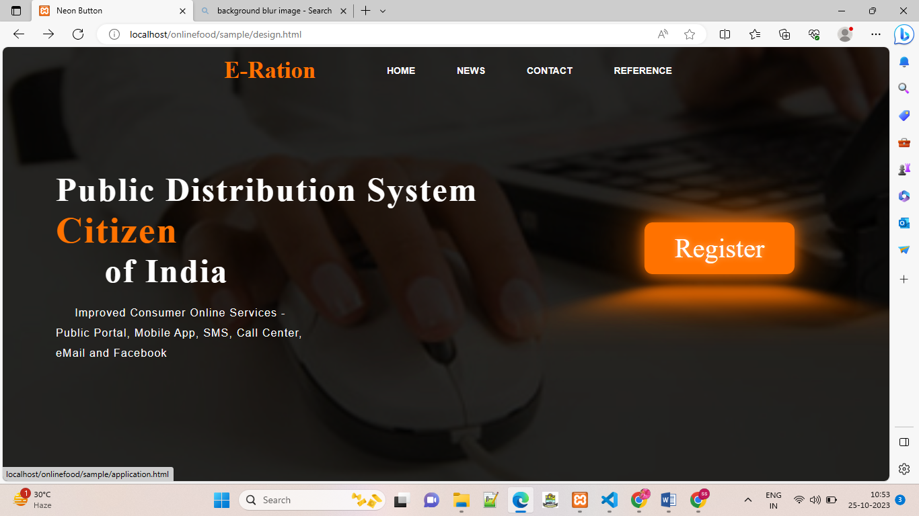

CONTUCT US THROUGH E-MAIL

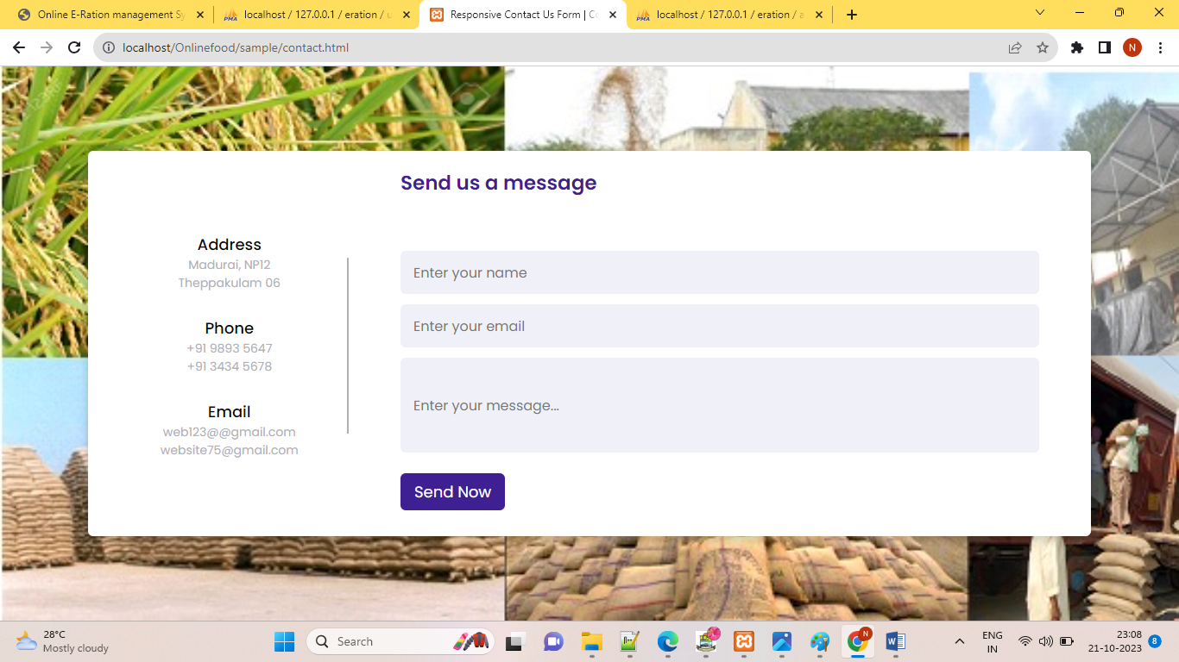

CHECKING A MESSAGE

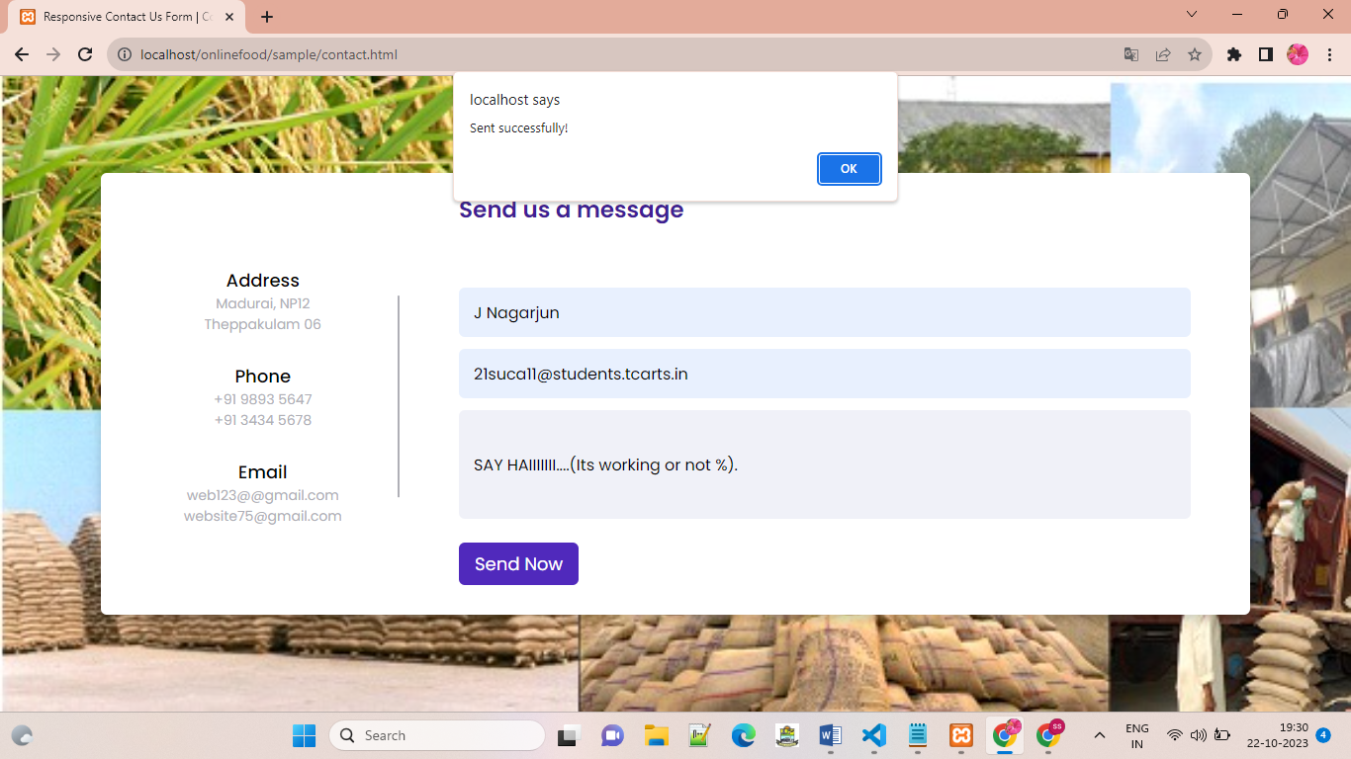

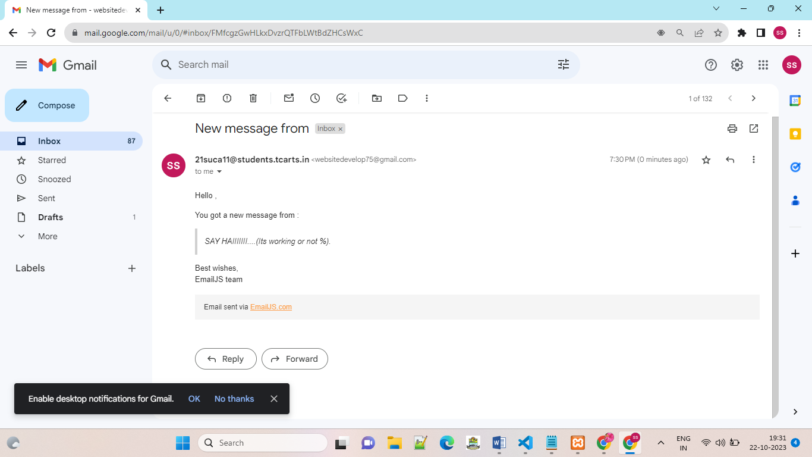

NEWS PAGE

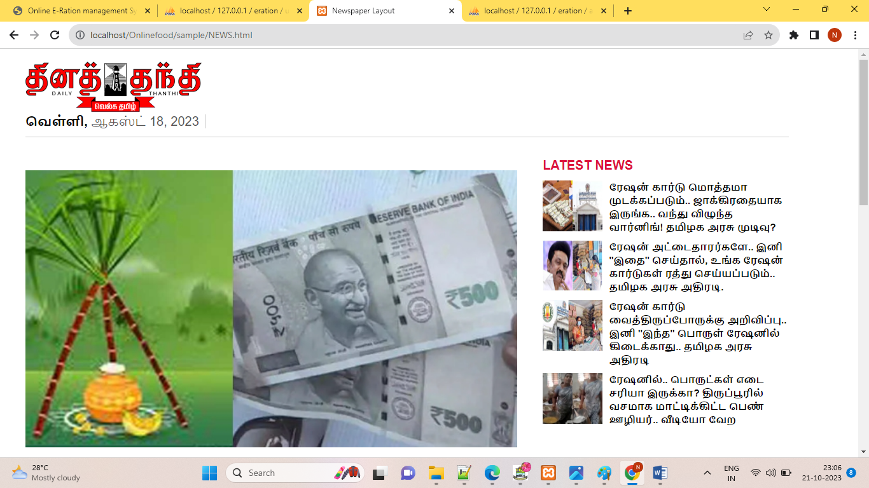

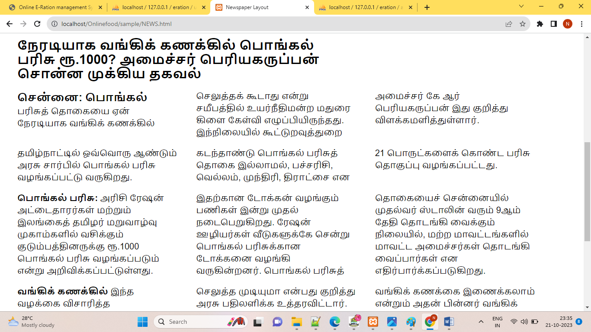

REGISTER FORM FOR USERS

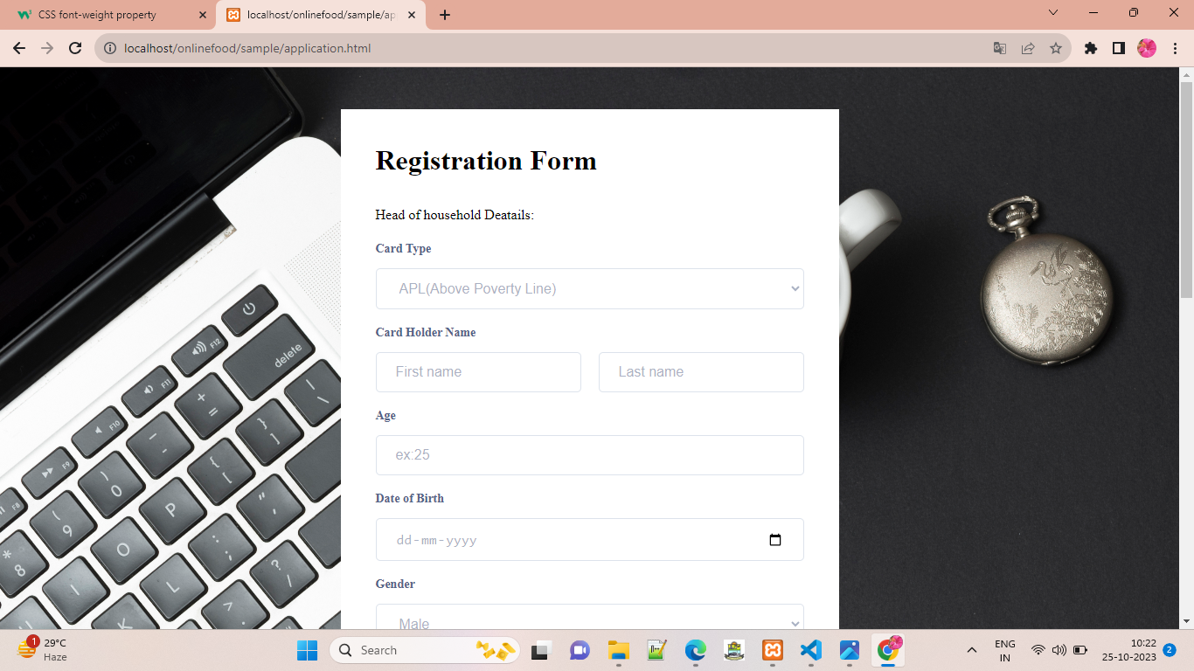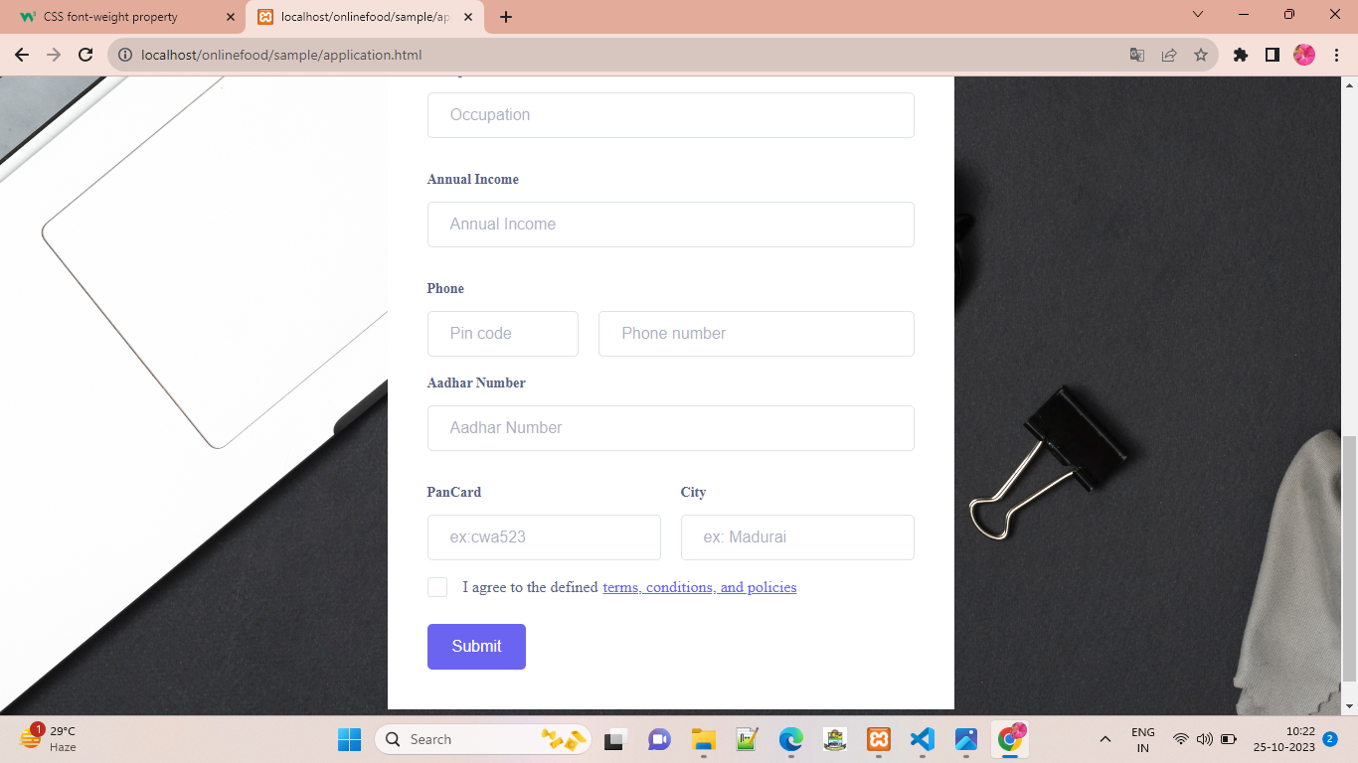

OTP VERIFICAION

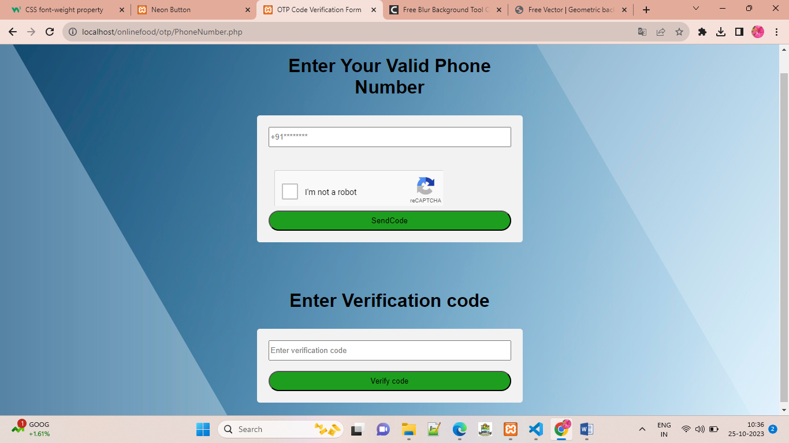

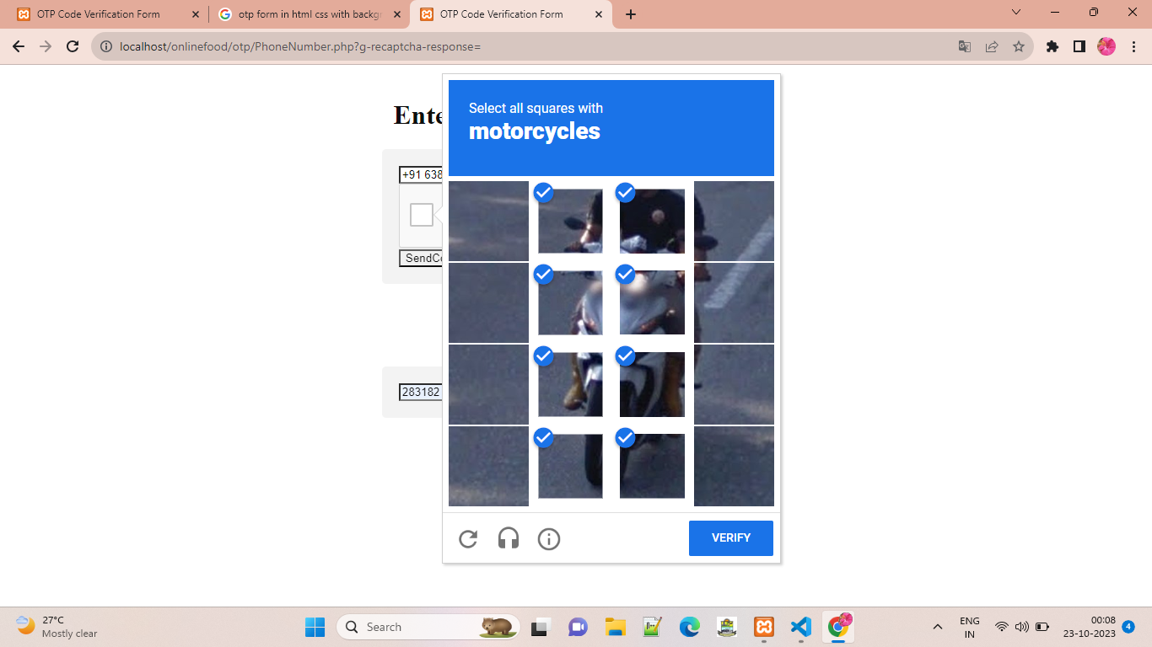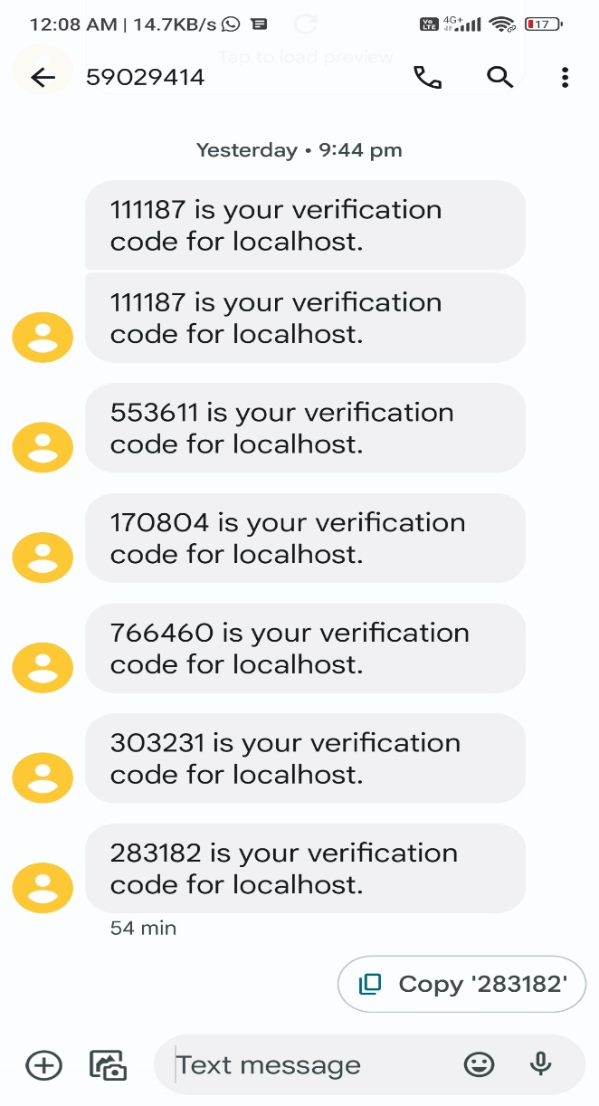

AFTER VERIFICATION

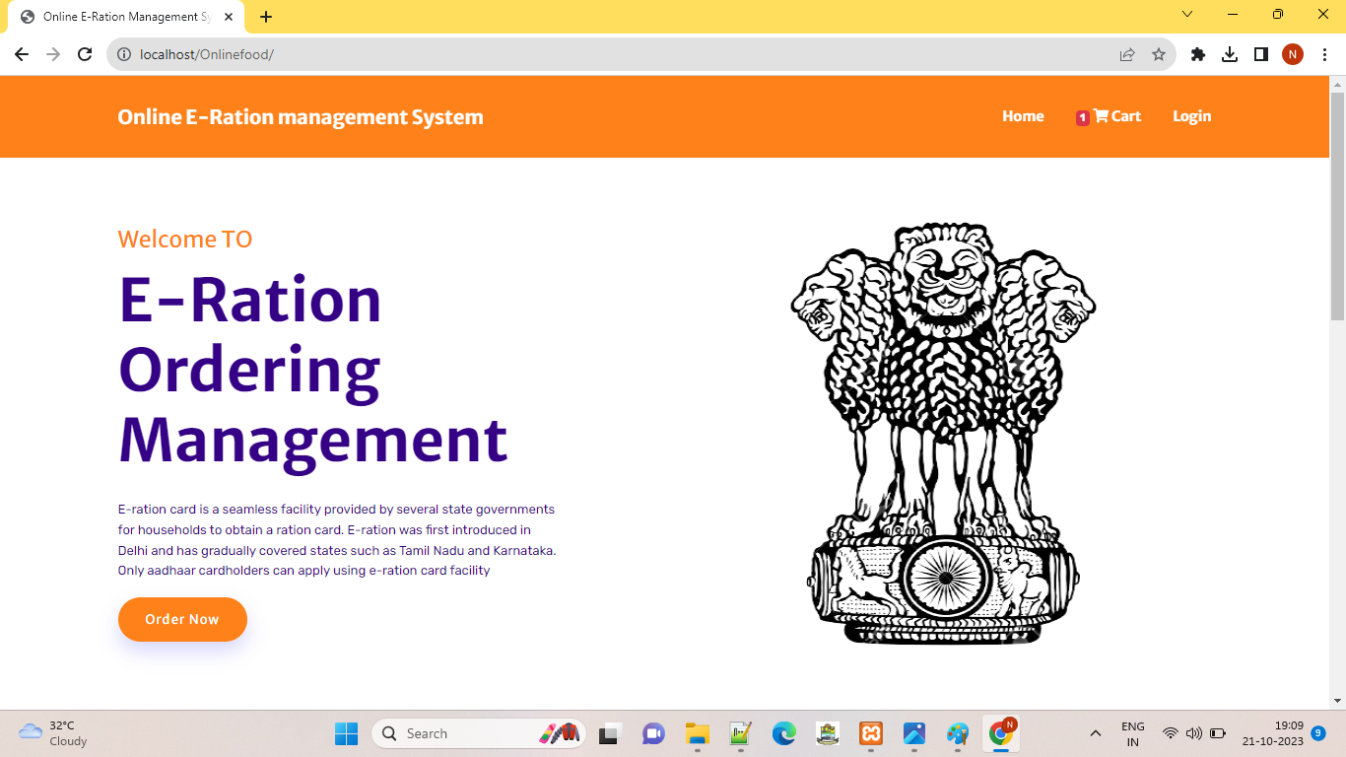

CREATE AN ACCOUNT

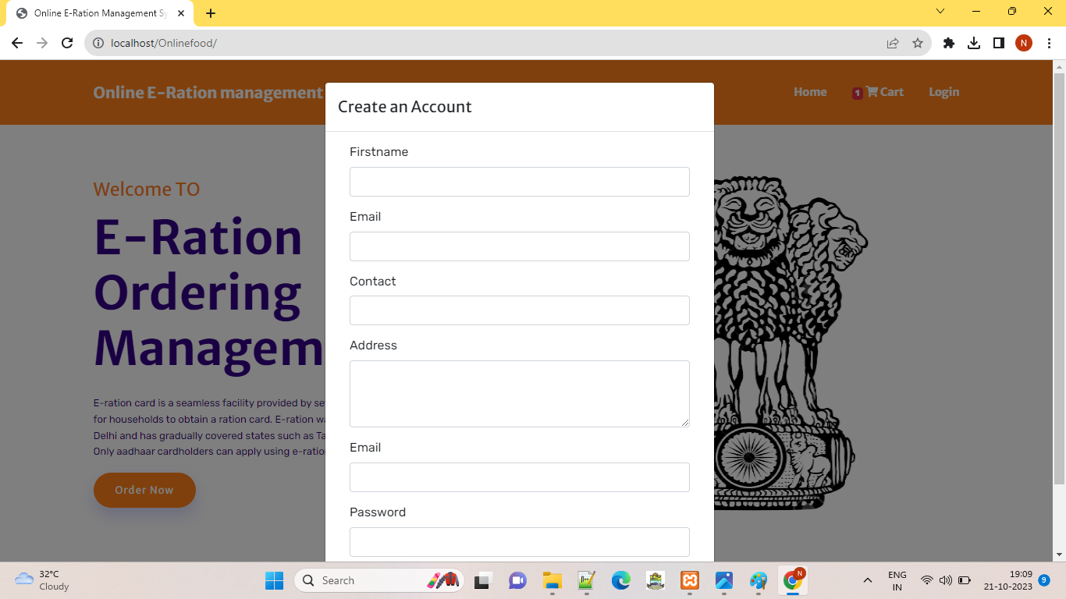

LOGIN USER

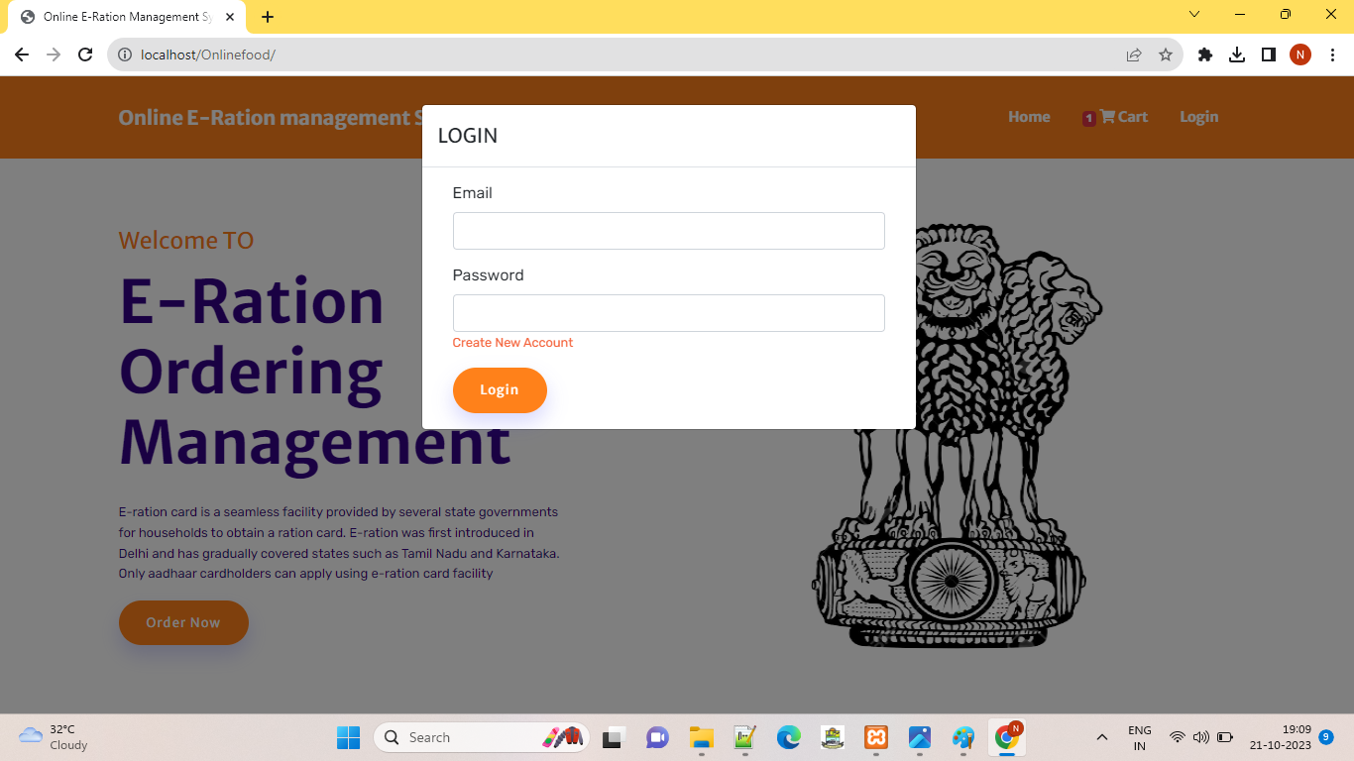

ORDER NOW

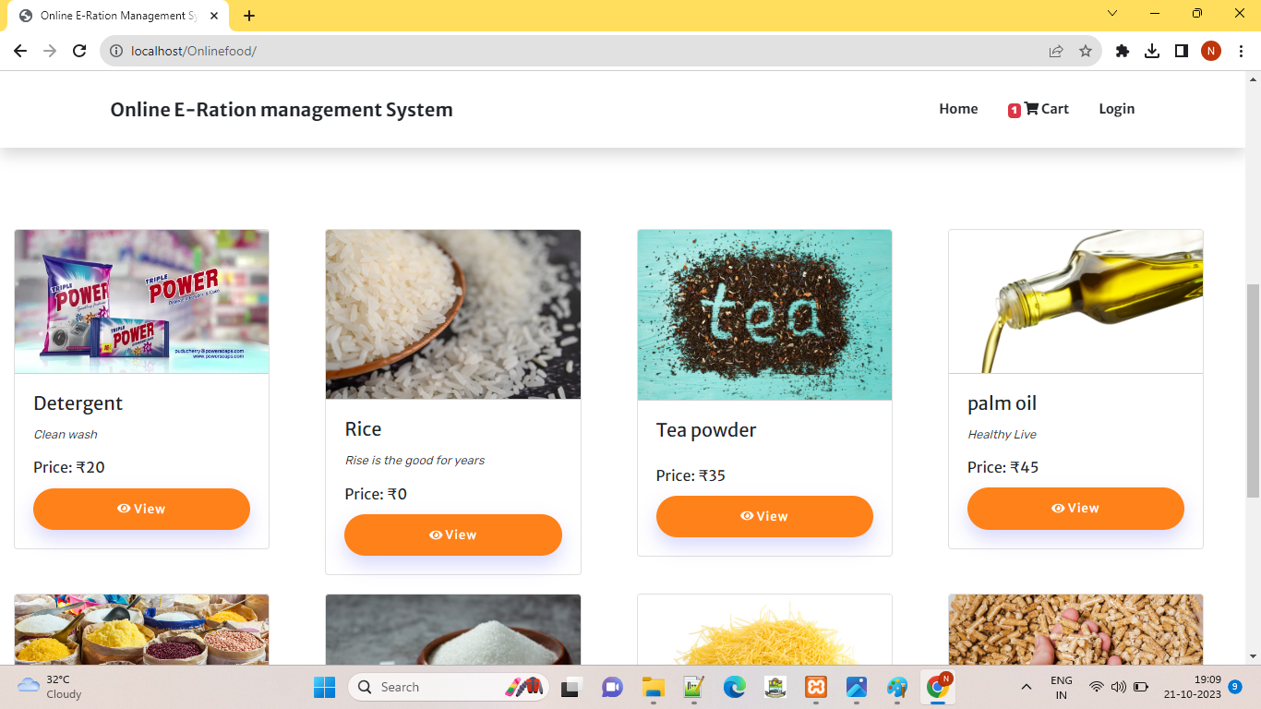

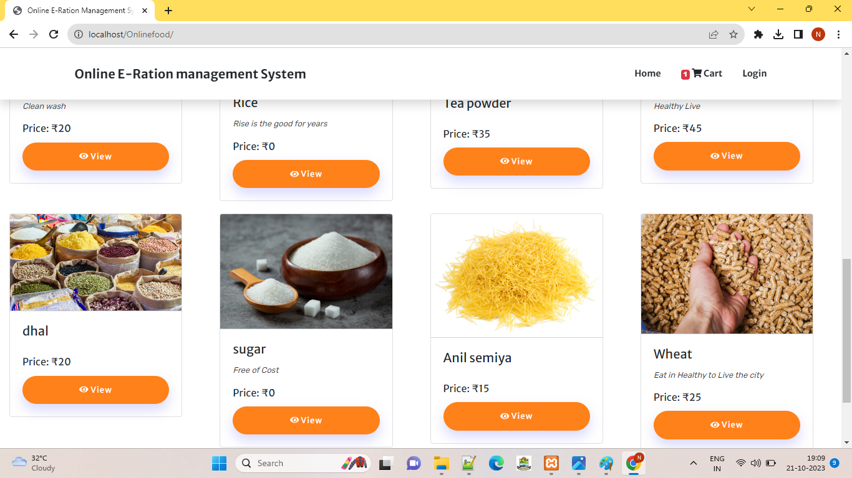

INSERT A CART

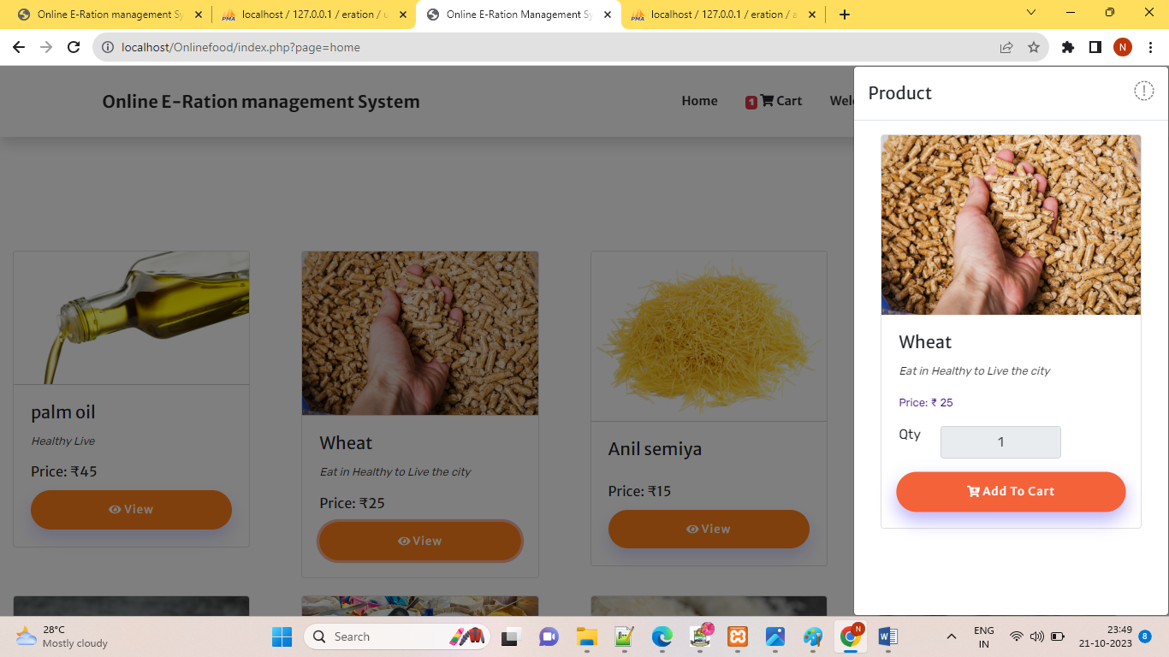

GO TO CART

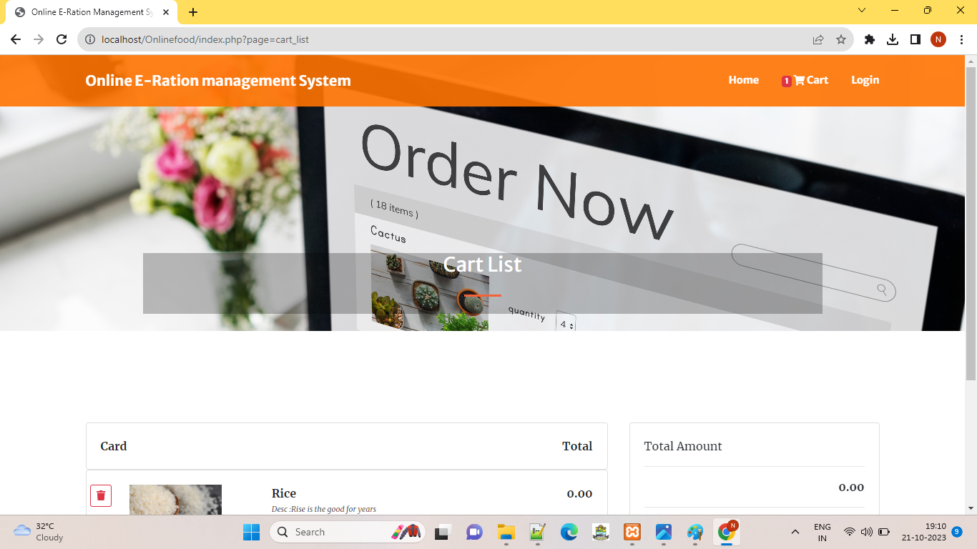

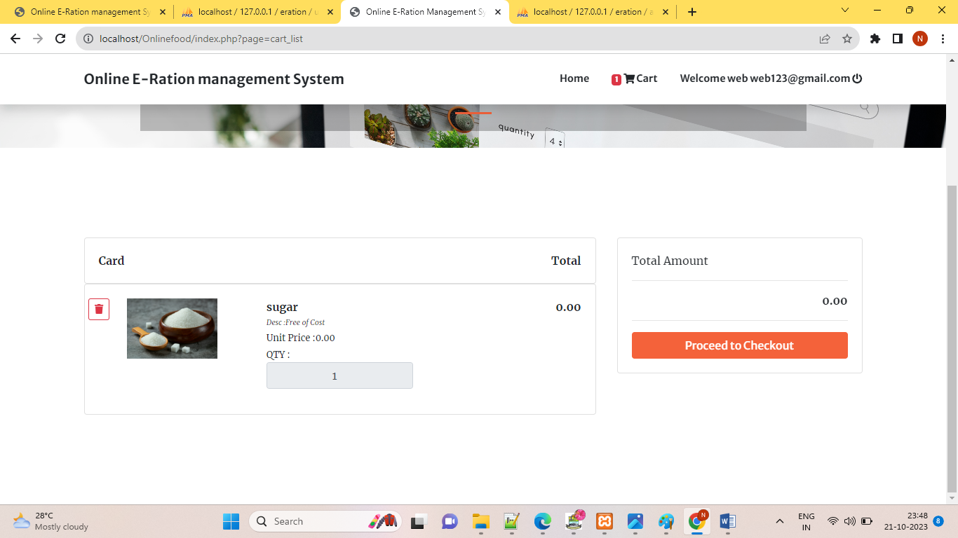

PROCEED TO CHECKOUT

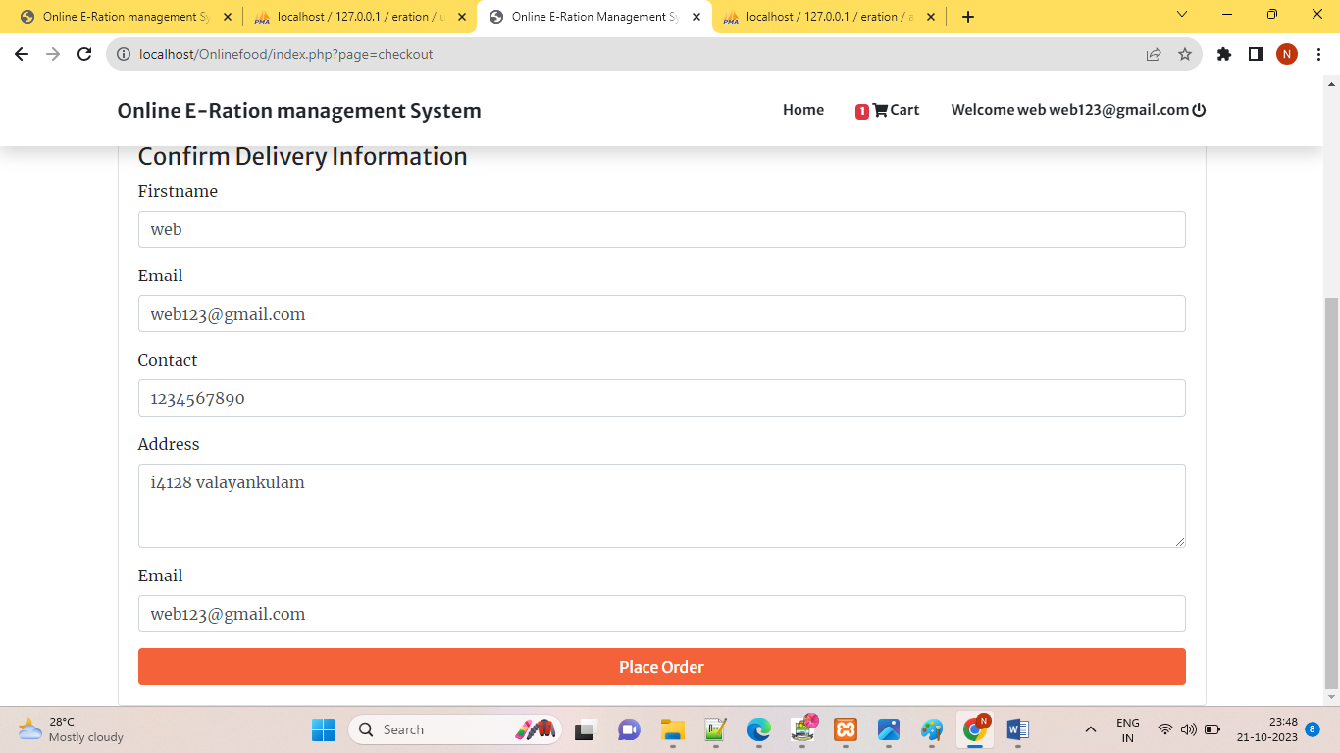

**(ADMIN MODULE)**

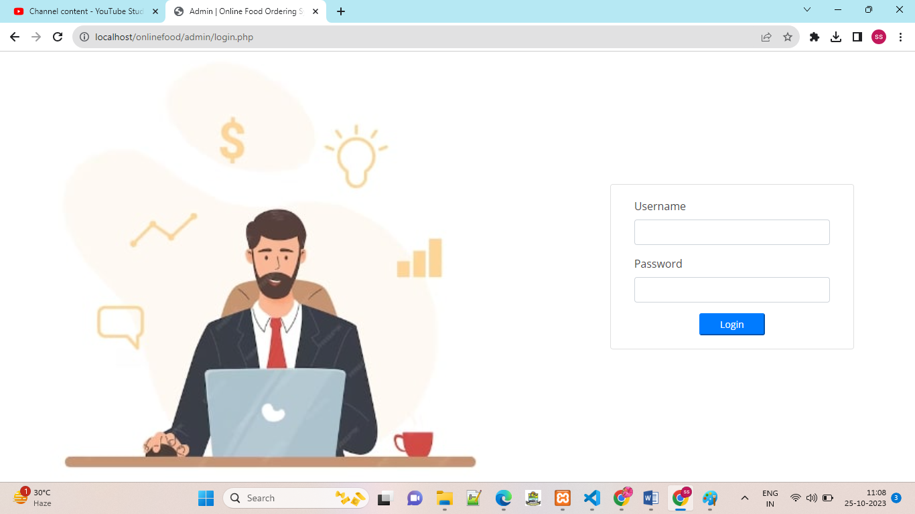

HOME

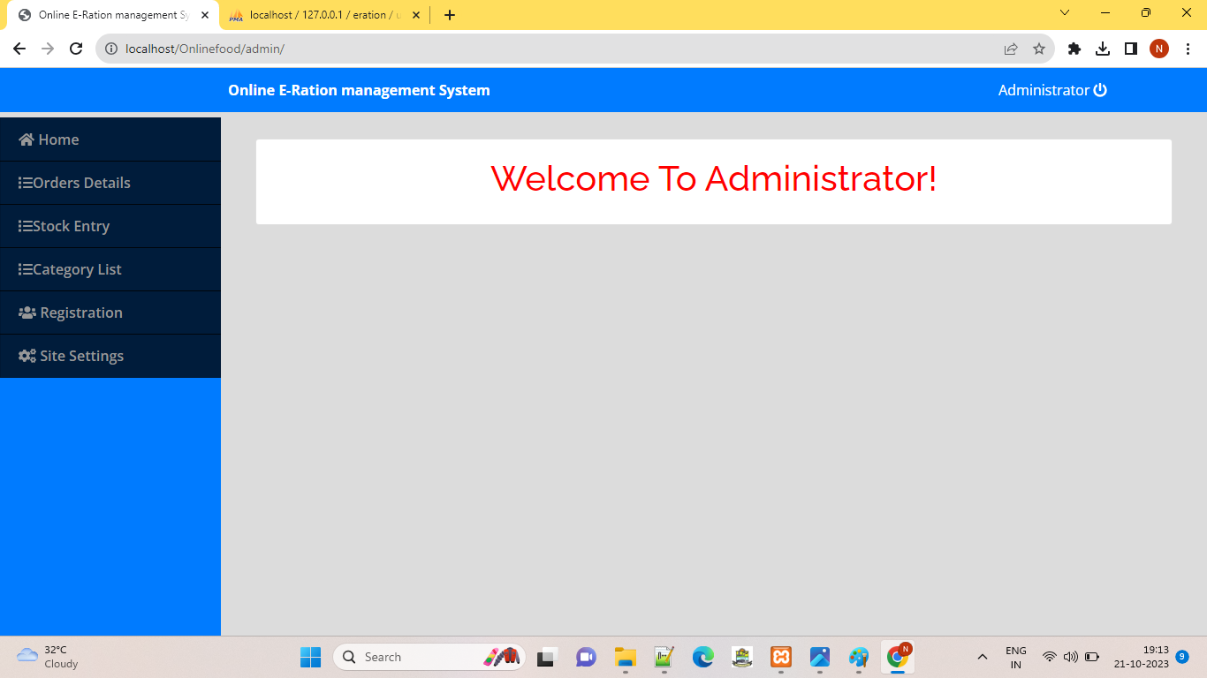

VIEWING THE ORDERING DETAILS

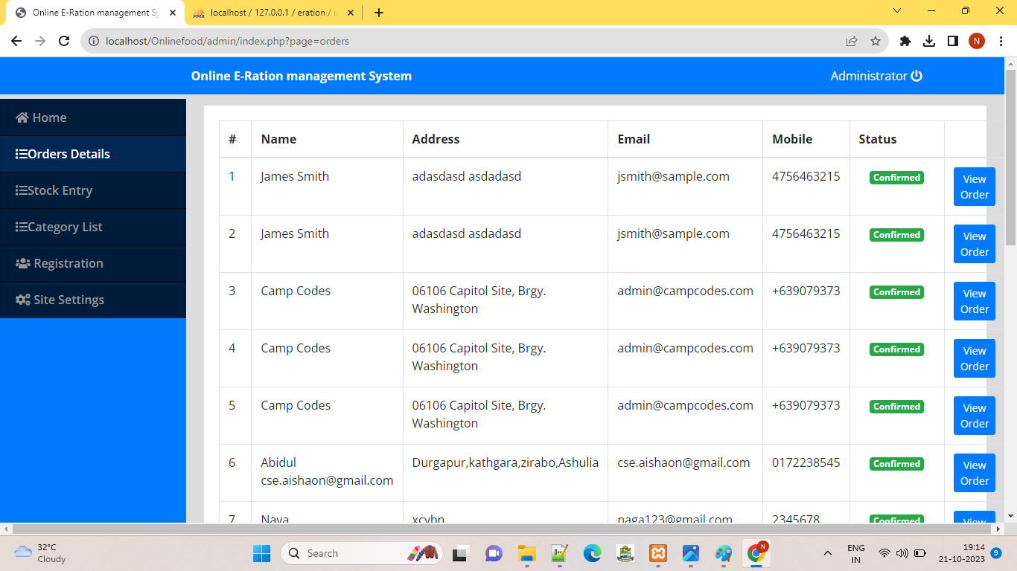

CONFORM OUR ORDER

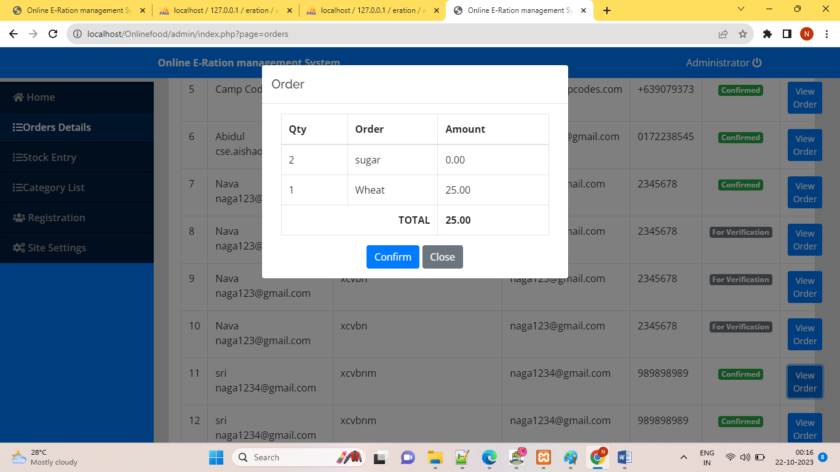

UPDATEING AND STOCK ENTRY

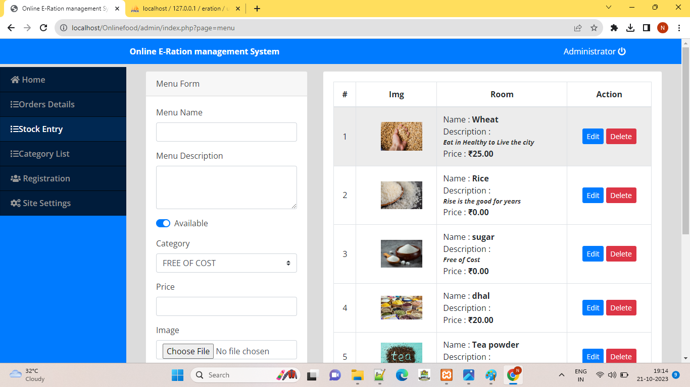

VIEWING THE CATEGORY LIST

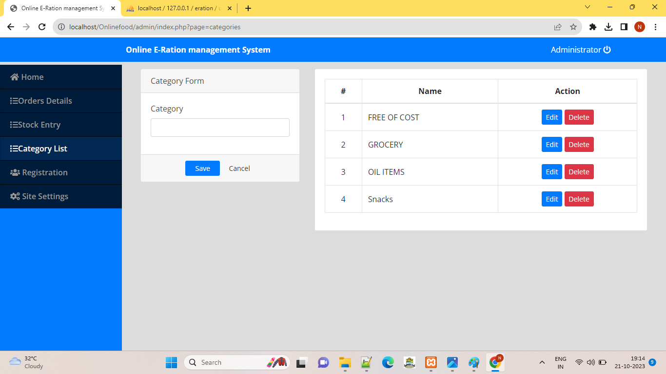

USER REGISTERATION

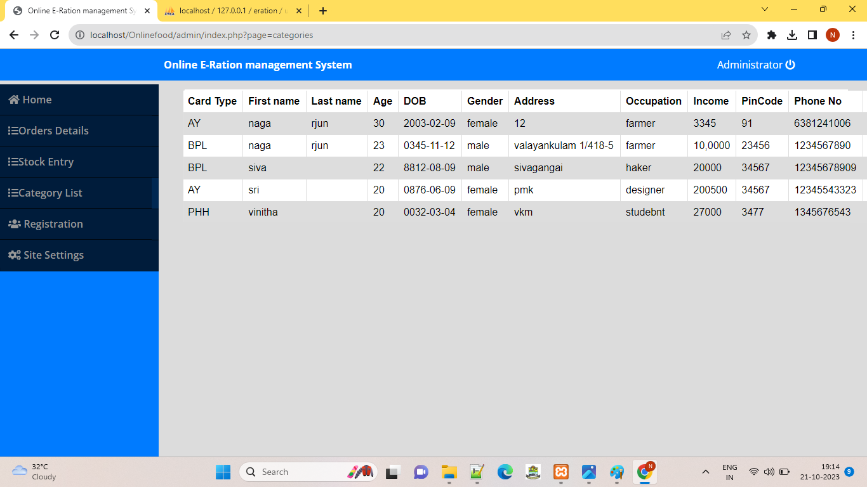

SITE SETTINGS

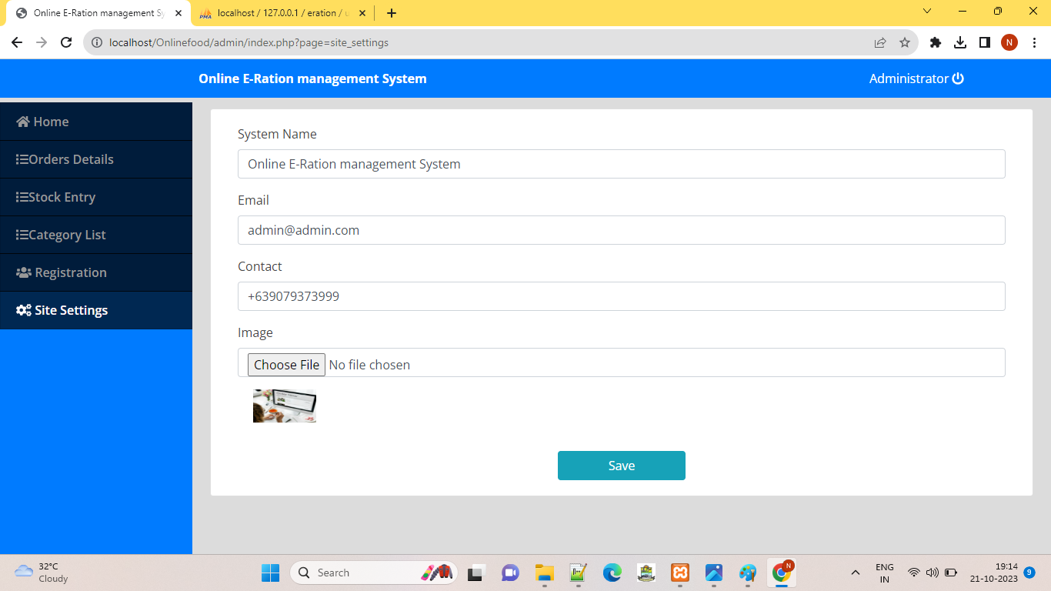

**5.5 SOURCE CODE**

**WEBHOME.HTML FILE**

<!DOCTYPE html>

<html lang="en">

<head>

<meta charset="UTF-8">

<meta http-equiv="X-UA-Compatible" content="IE=edge">

<meta name="viewport" content="width=device-width, initial-scale=1.0">

<link rel="stylesheet" href="stylebtn.css">

<title>Neon Button</title>

</head>

<head>

<title>Webpage Design</title>

<link rel="stylesheet" href="sdesign.css"

</head>

<body>

<div class="main">

<div class="navbar">

<div class="icon">

<h2 class="logo" style="font-family: 'Times New Roman', Times, serif;">E-Ration</h2>

</div>

<div class="menu">

<ul>

<li><a href="home.php?variableName='ValueOfVariable'">HOME</a></li>

<li><a href="NEWS.html">NEWS</a></li>

<li><a href="contact.html">CONTACT</a></li>

</ul>

</div>

</div>

<div class="content">

<h1>Public Distribution System <br><span>Citizen</span> <br>&nbsp;&nbsp;&nbsp;&nbsp;&nbsp;of India</h1><br>

<p class="par">&nbsp;&nbsp;&nbsp;&nbsp;&nbsp;Improved Consumer Online Services -<br> Public Portal, Mobile App, SMS, Call Center,<br> eMail and Facebook</p>

<div class="form">

<a href="application.html" class="neon" style="font-family: 'Times New Roman', Times, serif; text-decoration: none; color: white;">Register</a>

</div>

</div>

</div>

</div>

</div>

<script src="https://unpkg.com/ionicons@5.4.0/dist/ionicons.js"></script>

</body>

</html>

**CONTACT.HTML FILE**

<!DOCTYPE html>

<html lang="en" dir="ltr">

<head>

<meta charset="UTF-8">

<title> Responsive Contact Us Form | CodingLab </title>

<link rel="stylesheet" href="style.css">

<link rel="stylesheet" href="min.css"/>

<meta name="viewport" content="width=device-width, initial-scale=1.0">

<script type="text/javascript" src="https://cdn.jsdelivr.net/npm/emailjs-com@3/dist/email.min.js" > </script>

<script type="text/javascript">

(function() {

emailjs.init("34EQdz_jn57INFudJ");

})();

</script>

</head>

<body>

<div class="container">

<div class="content">

<div class="left-side">

<div class="address details">

<i class="fas fa-map-marker-alt"></i>

<div class="topic">Address</div>

<div class="text-one">Madurai, NP12</div>

<div class="text-two">Theppakulam 06</div>

</div>

<div class="phone details">

<i class="fas fa-phone-alt"></i>

<div class="topic">Phone</div>

<div class="text-one">+91 9893 5647</div>

<div class="text-two">+91 3434 5678</div>

</div>

<div class="email details">

<i class="fas fa-envelope"></i>

<div class="topic">Email</div>

<div class="text-one">web123@@gmail.com</div>

<div class="text-two">website75@gmail.com</div>

</div>

</div>

<div class="right-side">

<div class="topic-text">Send us a message</div>

<p>If you have any work from me or any types of quries related to my tutorial, you can send me message from here. It's my pleasure to help you.</p>

<form action="#">

<div class="input-box">

<input type="text" id="name" placeholder="Enter your name">

</div>

<div class="input-box">

<input type="text" id="email" placeholder="Enter your email">

</div>

<div class="input-box message-box">

<input type="text" id="message" placeholder="Enter your message...">

</div>

<div class="button">

<input type="button" onclick="sendemail()" value="Send Now" >

</div>

</form>

</div>

</div>

</div>

<script>

function sendemail(){

var email=document.getElementById("email").value;

var from_name=document.getElementById("name").value;

var message=document.getElementById("message").value;

var templateParams = {

email: email,

to_name: name ,

message: message

};

emailjs.send('service_j6j4tsm', 'template_ie3lgql', templateParams)

.then(function(response) {

console.log('SUCCESS!', response.status, response.text);

window.alert("Sent successfully!");

})

}

</script>

</body>

</html>

**HOME.PHP**

<link href="css/main.css" rel="stylesheet" />

<section class="home" id="home">

<div class="container">

<div class="home-wrapper d-grid">

<div class="col-left">

<h3>Welcome TO</h3>

<h1> E-Ration <br>Ordering Management</h1>

<p>E-ration card is a seamless facility provided by several state governments for households to obtain a ration card. E-ration was first introduced in Delhi and has gradually covered states such as Tamil Nadu and Karnataka. Only aadhaar cardholders can apply using e-ration card facility </p>

<a href="#" class="btn">Order Now</a>

</div>

<div class="col-right">

<img data-tilt src="emp1.png" alt="Home image" class="img-fluid">

</div>

</div>

</div>

</section>

<section class="page-section" id="menu">

<div id="menu-field" class="card-deck">

<?php

include'admin/db_connect.php';

$qry = $conn->query("SELECT * FROM product_list order by rand() ");

while($row = $qry->fetch_assoc()):

?>

<?php "<br>" ?>

<div class="col-lg-3" style="margin-bottom: 20px;">

<div class="card menu-item ">

<img src="assets/img/<?php echo $row['img_path'] ?>" class="card-img-top" alt="...">

<div class="card-body">

<h5 class="card-title"><?php echo $row['name'] ?></h5>

<p class="card-text truncate"><?php echo $row['description'] ?></p>

<h6 class="card-title">Price: ₹<?php echo $row['price'] ?></h6>

<div class="text-center">

<button class="btn btn-sm btn-outline-primary view_prod btn-block" data-id=<?php echo $row['id'] ?>><i class="fa fa-eye"></i> View</button>

</div>

</div>

</div>

</div>

<?php endwhile; ?>

</div>

</section>

<script>

$('.view_prod').click(function(){

uni_modal_right('Product','view_prod.php?id='+$(this).attr('data-id'))

})

</script>

**INDEX.PHP**

<!DOCTYPE html>

<html lang="en">

<?php

session_start();

include('header.php');

include('admin/db_connect.php');

$query = $conn->query("SELECT * FROM system_settings limit 1")->fetch_array();

foreach ($query as $key => $value) {

if(!is_numeric($key))

$_SESSION['setting_'.$key] = $value;

}

?>

<style>

header.masthead {

background: url(assets/img/<?php echo $_SESSION['setting_cover_img'] ?>);

background-repeat: no-repeat;

background-size: cover;

}

</style>

<body id="page-top">

<!-- Navigation-->

<div class="toast" id="alert_toast" role="alert" aria-live="assertive" aria-atomic="true">

<div class="toast-body text-white">

</div>

</div>

<nav class="navbar navbar-expand-lg navbar-light fixed-top py-3" id="mainNav">

<div class="container">

<a class="navbar-brand js-scroll-trigger" href="./"><?php echo $_SESSION['setting_name'] ?></a>

<button class="navbar-toggler navbar-toggler-right" type="button" data-toggle="collapse" data-target="#navbarResponsive" aria-controls="navbarResponsive" aria-expanded="false" aria-label="Toggle navigation"><span class="navbar-toggler-icon"></span></button>

<div class="collapse navbar-collapse" id="navbarResponsive">

<ul class="navbar-nav ml-auto my-2 my-lg-0">

<li class="nav-item"><a class="nav-link js-scroll-trigger" href="index.php?page=home">Home</a></li>

<li class="nav-item"><a class="nav-link js-scroll-trigger" href="index.php?page=cart_list"><span> <span class="badge badge-danger item_count">0</span> <i class="fa fa-shopping-cart"></i> </span>Cart</a></li>

<?php if(isset($_SESSION['login_user_id'])): ?>

<li class="nav-item"><a class="nav-link js-scroll-trigger" href="admin/ajax.php?action=logout2"><?php echo "Welcome ". $_SESSION['login_first_name'].' '.$_SESSION['login_last_name'] ?> <i class="fa fa-power-off"></i></a></li>

<?php else: ?>

<li class="nav-item"><a class="nav-link js-scroll-trigger" href="javascript:void(0)" id="login_now">Login</a></li>

<?php endif; ?>

</ul>

</div>

</div>

</nav>

<?php

$page = isset($_GET['page']) ?$_GET['page'] : "home";

include $page.'.php';

?>

<div class="modal fade" id="confirm_modal" role='dialog'>

<div class="modal-dialog modal-md" role="document">

<div class="modal-content">

<div class="modal-header">

<h5 class="modal-title">Confirmation</h5>

</div>

<div class="modal-body">

<div id="delete_content"></div>

</div>

<div class="modal-footer">

<button type="button" class="btn btn-primary" id='confirm' onclick="">Continue</button>

<button type="button" class="btn btn-secondary" data-dismiss="modal">Close</button>

</div>

</div>

</div>

</div>

<div class="modal fade" id="uni_modal" role='dialog'>

<div class="modal-dialog modal-md" role="document">

<div class="modal-content">

<div class="modal-header">

<h5 class="modal-title"></h5>

</div>

<div class="modal-body">

</div>

<div class="modal-footer">

<button type="button" class="btn btn-primary" id='submit' onclick="$('#uni_modal form').submit()">Save</button>

<button type="button" class="btn btn-secondary" data-dismiss="modal">Cancel</button>

</div>

</div>

</div>

</div>

<div class="modal fade" id="uni_modal_right" role='dialog'>

<div class="modal-dialog modal-full-height modal-md" role="document">

<div class="modal-content">

<div class="modal-header">

<h5 class="modal-title"></h5>

<button type="button" class="close" data-dismiss="modal" aria-label="Close">

<span class="fa fa-arrow-righ t"></span>

</button>

</div>

<div class="modal-body">

</div>

</div>

</div>

</div>

<?php include('footer.php') ?>

</body>

<?php $conn->close() ?>

</html>

**LOGIN.PHP FILE**

<?php session_start() ?>

<div class="container-fluid">

<form action="" id="login-frm">

<div class="form-group">

<label for="" class="control-label">Email</label>

<input type="email" name="email" required="" class="form-control">

</div>

<div class="form-group">

<label for="" class="control-label">Password</label>

<input type="password" name="password" required="" class="form-control">

<small><a href="javascript:void(0)" id="new_account">Create New Account</a></small>

</div>

<button class="button btn btn-info btn-sm">Login</button>

</form>

</div>

<style>

#uni_modal .modal-footer{

display:none;

}

</style>

<script>

$('#new_account').click(function(){

uni_modal("Create an Account",'signup.php?redirect=index.php?page=checkout')

})

$('#login-frm').submit(function(e){

e.preventDefault()

$('#login-frm button[type="submit"]').attr('disabled',true).html('Logging in...');

if($(this).find('.alert-danger').length > 0 )

$(this).find('.alert-danger').remove();

$.ajax({

url:'admin/ajax.php?action=login2',

method:'POST',

data:$(this).serialize(),

error:err=>{

console.log(err)

$('#login-frm button[type="submit"]').removeAttr('disabled').html('Login');

},

success:function(resp){

if(resp == 1){

location.href ='<?php echo isset($_GET['redirect']) ? $_GET['redirect'] : 'index.php?page=home' ?>';

}else{

$('#login-frm').prepend('<div class="alert alert-danger">Email or password is incorrect.</div>')

$('#login-frm button[type="submit"]').removeAttr('disabled').html('Login');

}

}

})

})

</script>

**SIGNUP.PHP FILE**

<?php session_start() ?>

<div class="container-fluid">

<form action="" id="signup-frm">

<div class="form-group">

<label for="" class="control-label">Firstname</label>

<input type="text" name="first_name" required="" class="form-control">

</div>

<div class="form-group">

<label for="" class="control-label">Email</label>

<input type="text" name="last_name" required="" class="form-control">

</div>

<div class="form-group">

<label for="" class="control-label">Contact</label>

<input type="text" name="mobile" required="" class="form-control">

</div>

<div class="form-group">

<label for="" class="control-label">Address</label>

<textarea cols="30" rows="3" name="address" required="" class="form-control"></textarea>

</div>

<div class="form-group">

<label for="" class="control-label">Email</label>

<input type="email" name="email" required="" class="form-control">

</div>

<div class="form-group">

<label for="" class="control-label">Password</label>

<input type="password" name="password" required="" class="form-control">

</div>

<button class="button btn btn-info btn-sm">Create</button>

</form>

</div>

<style>

#uni_modal .modal-footer{

display:none;

}

</style>

<script>

$('#signup-frm').submit(function(e){

e.preventDefault()

$('#signup-frm button[type="submit"]').attr('disabled',true).html('Saving...');

if($(this).find('.alert-danger').length > 0 )

$(this).find('.alert-danger').remove();

$.ajax({

url:'admin/ajax.php?action=signup',

method:'POST',

data:$(this).serialize(),

error:err=>{

console.log(err)

$('#signup-frm button[type="submit"]').removeAttr('disabled').html('Create');

},

success:function(resp){

if(resp == 1){

location.href ='<?php echo isset($_GET['redirect']) ? $_GET['redirect'] : 'index.php?page=home' ?>';

}

else{

$('#signup-frm').prepend('<div class="alert alert-danger">Email already exist.</div>')

$('#signup-frm button[type="submit"]').removeAttr('disabled').html('Create');

}

}

})

})

</script>

**CARTLIST.PHP FILE**

<!-- Masthead-->

<header class="masthead">

<div class="container h-100">

<div class="row h-100 align-items-center justify-content-center text-center">

<div class="col-lg-10 align-self-end mb-4 page-title">

<h3 class="text-white">Cart List</h3>

<hr class="divider my-4" />

</div>

</div>

</div>

</header>

<section class="page-section" id="menu">

<div class="container">

<div class="row">

<div class="col-lg-8">

<div class="sticky">

<div class="card">

<div class="card-body">

<div class="row">

<div class="col-md-8"><b>Card</b></div>

<div class="col-md-4 text-right"><b>Total</b></div>

</div>

</div>

</div>

</div>

<?php

if(isset($_SESSION['login_user_id'])){

$data = "where c.user_id = '".$_SESSION['login_user_id']."' ";

}

else{

$ip = isset($_SERVER['HTTP_CLIENT_IP']) ? $_SERVER['HTTP_CLIENT_IP'] : isset($_SERVER['HTTP_X_FORWARDED_FOR']) ? $_SERVER['HTTP_X_FORWARDED_FOR'] : $_SERVER['REMOTE_ADDR'];

$data = "where c.client_ip = '".$ip."' ";

}

$total = 0;

$get = $conn->query("SELECT *,c.id as cid FROM cart c inner join product_list p on p.id = c.product_id ".$data);

while($row= $get->fetch_assoc()):

$total += ($row['qty'] * $row['price']);

?>

<div class="card">

<div class="card-body">

<div class="row">

<div class="col-md-4" style="text-align: -webkit-center">

<a href="javascript:void(0)" class="rem_cart btn btn-sm btn-outline-danger" data-id="<?php echo $row['cid'] ?>"><i class="fa fa-trash"></i></a>

<img src="assets/img/<?php echo $row['img_path'] ?>" alt="">

</div>

<div class="col-md-4">

<p><b><large><?php echo $row['name'] ?></large></b></p>

<p class='truncate'> <b><small>Desc :<?php echo $row['description'] ?></small></b></p>

<p> <b><small>Unit Price :<?php echo number_format($row['price'],2) ?></small></b></p>

<p><small>QTY :</small></p>

<div class="input-group mb-3">

<input type="number" readonly value="<?php echo $row['qty'] ?>" min = 1 class="form-control text-center" name="qty" >

</div>

</div>

<div class="col-md-4 text-right">

<b><large><?php echo number_format($row['qty'] * $row['price'],2) ?></large></b>

</div>

</div>

</div>

</div>

<?php endwhile; ?>

</div>

<div class="col-md-4">

<div class="sticky">

<div class="card">

<div class="card-body">

<p><large>Total Amount</large></p>

<hr>

<p class="text-right"><b><?php echo number_format($total,2) ?></b></p>

<hr>

<div class="text-center">

<button class="btn btn-block btn-outline-primary" type="button" id="checkout">Proceed to Checkout</button>

</div>

</div>

</div>

</div>

</div>

</div>

</div>

</section>

<style>

.card p {

margin: unset

}

.card img{

max-width: calc(100%);

max-height: calc(59%);

}

div.sticky {

position: -webkit-sticky; /* Safari */

position: sticky;

top: 4.7em;

z-index: 10;

background: white

}

.rem_cart{

position: absolute;

left: 0;

}

</style>

<script>

$('.view_prod').click(function(){

uni_modal_right('Product','view_prod.php?id='+$(this).attr('data-id'))

})

$('.qty-minus').click(function(){

var qty = $(this).parent().siblings('input[name="qty"]').val();

update_qty(parseInt(qty) -1,$(this).attr('data-id'))

if(qty == 1){

return false;

}else{

$(this).parent().siblings('input[name="qty"]').val(parseInt(qty) -1);

}

})

$('.qty-plus').click(function(){

var qty = $(this).parent().siblings('input[name="qty"]').val();

$(this).parent().siblings('input[name="qty"]').val(parseInt(qty) +1);

update_qty(parseInt(qty) +1,$(this).attr('data-id'))

})

function update_qty(qty,id){

start_load()

$.ajax({

url:'admin/ajax.php?action=update_cart_qty',

method:"POST",

data:{id:id,qty},

success:function(resp){

if(resp == 1){

load_cart()

end_load()

}

}

})

}

$('#checkout').click(function(){

if('<?php echo isset($_SESSION['login_user_id']) ?>' == 1){

location.replace("index.php?page=checkout")

}else{

uni_modal("Checkout","login.php?page=checkout")

}

})

</script>

**CHECKOUT.PHP FILE**

<header class="masthead">

<div class="container h-100">

<div class="row h-100 align-items-center justify-content-center text-center">

<div class="col-lg-10 align-self-end mb-4 page-title">

<h3 class="text-white">Checkout</h3>

<hr class="divider my-4" />

</div>

</div>

</div>

</header>

<div class="container">

<div class="card">

<div class="card-body">

<form action="" id="checkout-frm">

<h4>Confirm Delivery Information</h4>

<div class="form-group">

<label for="" class="control-label">Firstname</label>

<input type="text" name="first_name" required="" class="form-control" value="<?php echo $_SESSION['login_first_name'] ?>">

</div>

<div class="form-group">

<label for="" class="control-label">Email</label>

<input type="text" name="last_name" required="" class="form-control" value="<?php echo $_SESSION['login_last_name'] ?>">

</div>

<div class="form-group">

<label for="" class="control-label">Contact</label>

<input type="text" name="mobile" required="" class="form-control" value="<?php echo $_SESSION['login_mobile'] ?>">

</div>

<div class="form-group">

<label for="" class="control-label">Address</label>

<textarea cols="30" rows="3" name="address" required="" class="form-control"><?php echo $_SESSION['login_address'] ?></textarea>

</div>

<div class="form-group">

<label for="" class="control-label">Email</label>

<input type="email" name="email" required="" class="form-control" value="<?php echo $_SESSION['login_email'] ?>">

</div>

<div class="text-center">

<button class="btn btn-block btn-outline-primary">Place Order</button>

</div>

</form>

</div>

</div>

</div>

<script>

$(document).ready(function(){

$('#checkout-frm').submit(function(e){

e.preventDefault()

start_load()

$.ajax({

url:"admin/ajax.php?action=save_order",

method:'POST',

data:$(this).serialize(),

success:function(resp){

if(resp==1){

alert_toast("Order successfully Placed.")

setTimeout(function(){

location.replace('index.php?page=home')

},1500)

}

}

})

})

})

</script>

**VIEW_PROD.PHP FILE**

<?php

include'admin/db_connect.php';

$qry = $conn->query("SELECT * FROM product_list where id = ".$_GET['id'])->fetch_array();

?>

<div class="container-fluid">

<div class="card ">

<img src="assets/img/<?php echo $qry['img_path'] ?>" class="card-img-top" alt="...">

<div class="card-body">

<h5 class="card-title"><?php echo $qry['name'] ?></h5>

<p class="card-text truncate"><?php echo $qry['description'] ?></p>

<p class="card-text">Price: ₹ <?php echo $qry['price'] ?></p>

<div class="form-group">

</div>

<div class="row">

<div class="col-md-2"><label class="control-label">Qty</label></div>

<div class="input-group col-md-7 mb-3">

<input type="text" readonly value="1" min = 1 class="form-control text-center" name="qty" >

</div>

</div>

<div class="text-center">

<button class="btn btn-outline-primary btn-sm btn-block" id="add_to_cart_modal"><i class="fa fa-cart-plus"></i> Add to Cart</button>

</div>

</div>

</div>

</div>

<style>

#uni_modal_right .modal-footer{

display: none;

}

</style>

<script>

$('#qty-minus').click(function(){

var qty = $('input[name="qty"]').val();

if(qty == 1){

return false;

}else{

$('input[name="qty"]').val(parseInt(qty) -1);

}

})

$('#qty-plus').click(function(){

var qty = $('input[name="qty"]').val();

$('input[name="qty"]').val(parseInt(qty) +1);

})

$('#add_to_cart_modal').click(function(){

start_load()

$.ajax({

url:'admin/ajax.php?action=add_to_cart',

method:'POST',

data:{pid:'<?php echo $_GET['id'] ?>',qty:$('[name="qty"]').val()},

success:function(resp){

if(resp == 1 )

alert_toast("Order successfully added to cart");

$('.item_count').html(parseInt($('.item_count').html()) + parseInt($('[name="qty"]').val()))

$('.modal').modal('hide')

end_load()

}

})

})

</script>

**DB_CONNECT.PHP FILE**

<?php

$conn= new mysqli('localhost','root','','eration')or die("Could not connect to mysql".mysqli_error($con));

? >

**HOME.PHP FILE**

<style>

.custom-menu {

z-index: 1000;

position: ahomesolute;

background-color: #ffffff;

border: 1px solid #0000001c;

border-radius: 5px;

padding: 8px;

min-width: 13vw;

}

a.custom-menu-list {

width: 100%;

display: flex;

color: #4c4b4b;

font-weight: 600;

font-size: 1em;

padding: 1px 11px;

}

span.card-icon {

position: absolute;

font-size: 3em;

bottom: .2em;

color: #ffffff80;

}

.file-item{

cursor: pointer;

}

a.custom-menu-list:hover,.file-item:hover,.file-item.active {

background: #80808024;

}

table th,td{

/*border-left:1px solid gray;*/

}

a.custom-menu-list span.icon{

width:1em;

margin-right: 5px

}

.candidate {

margin: auto;

width: 23vw;

padding: 0 10px;

border-radius: 20px;

margin-bottom: 1em;

display: flex;

border: 3px solid #00000008;

background: #8080801a;

}

.candidate_name {

margin: 8px;

margin-left: 3.4em;

margin-right: 3em;

width: 100%;

}

.img-field {

display: flex;

height: 8vh;

width: 4.3vw;

padding: .3em;

background: #80808047;

border-radius: 50%;

position: absolute;

left: -.7em;

top: -.7em;

}

.candidate img {

heigh

width: 100%;

margin: auto;

border-radius: 50%;

}

.vote-field {

position: absolute;

right: 0;

bottom: -.4em;

}

</style>

<div class="containe-fluid">

<div class="row">

<div class="col-lg-12">

</div>

</div>

<div class="row mt-3 ml-3 mr-3">

<div class="col-lg-12">

<div class="card">

<div class="card-body" style="text-align: center; color: red;">

<h1><?php echo "Welcome To ".$_SESSION['login_name']."!" ?></h1>

</div>

</div>

</div>

</div>

</div>

</div>

<script>

</script>

**ADMINCLASS.PHP FILE**

<?php

session_start();

Class Action {

private $db;

public function __construct() {

ob_start();

include 'db_connect.php';

$this->db = $conn;

}

function __destruct() {

$this->db->close();

ob_end_flush();

}

function login(){

extract($_POST);

$qry = $this->db->query("SELECT * FROM users where username = '".$username."' and password = '".$password."' ");

if($qry->num_rows > 0){

foreach ($qry->fetch_array() as $key => $value) {

if($key != 'passwors' && !is_numeric($key))

$_SESSION['login_'.$key] = $value;

}

return 1;

}else{

return 3;

}

}

function login2(){

extract($_POST);

$qry = $this->db->query("SELECT * FROM user_info where email = '".$email."' and password = '".md5($password)."' ");

if($qry->num_rows > 0){

foreach ($qry->fetch_array() as $key => $value) {

if($key != 'passwors' && !is_numeric($key))

$_SESSION['login_'.$key] = $value;

}

$ip = isset($_SERVER['HTTP_CLIENT_IP']) ? $_SERVER['HTTP_CLIENT_IP'] : isset($_SERVER['HTTP_X_FORWARDED_FOR']) ? $_SERVER['HTTP_X_FORWARDED_FOR'] : $_SERVER['REMOTE_ADDR'];

$this->db->query("UPDATE cart set user_id = '".$_SESSION['login_user_id']."' where client_ip ='$ip' ");

return 1;

}else{

return 3;

}

}

function logout(){

session_destroy();

foreach ($_SESSION as $key => $value) {

unset($_SESSION[$key]);

}

header("location:login.php");

}

function logout2(){

session_destroy();

foreach ($_SESSION as $key => $value) {

unset($_SESSION[$key]);

}

header("location:../index.php");

}

function save_user(){

extract($_POST);

$data = " name = '$name' ";

$data .= ", username = '$username' ";

$data .= ", password = '$password' ";

$data .= ", type = '$type' ";

if(empty($id)){

$save = $this->db->query("INSERT INTO users set ".$data);

}else{

$save = $this->db->query("UPDATE users set ".$data." where id = ".$id);

}

if($save){

return 1;

}

}

function signup(){

extract($_POST);

$data = " first_name = '$first_name' ";

$data .= ", last_name = '$last_name' ";

$data .= ", mobile = '$mobile' ";

$data .= ", address = '$address' ";

$data .= ", email = '$email' ";

$data .= ", password = '".md5($password)."' ";

$chk = $this->db->query("SELECT * FROM user_info where email = '$email' ")->num_rows;

if($chk > 0){

return 2;

exit;

}

$save = $this->db->query("INSERT INTO user_info set ".$data);

if($save){

$login = $this->login2();

return 1;

}

}

function save_settings(){

extract($_POST);

$data = " name = '$name' ";

$data .= ", email = '$email' ";

$data .= ", contact = '$contact' ";

$data .= ", about_content = '".htmlentities(str_replace("'","&#x2019;",$about))."' ";

if($_FILES['img']['tmp_name'] != ''){

$fname = strtotime(date('y-m-d H:i')).'_'.$_FILES['img']['name'];

$move = move_uploaded_file($_FILES['img']['tmp_name'],'../assets/img/'. $fname);

$data .= ", cover_img = '$fname' ";

}

// echo "INSERT INTO system_settings set ".$data;

$chk = $this->db->query("SELECT * FROM system_settings");

if($chk->num_rows > 0){

$save = $this->db->query("UPDATE system_settings set ".$data." where id =".$chk->fetch_array()['id']);

}else{

$save = $this->db->query("INSERT INTO system_settings set ".$data);

}

if($save){

$query = $this->db->query("SELECT * FROM system_settings limit 1")->fetch_array();

foreach ($query as $key => $value) {

if(!is_numeric($key))

$_SESSION['setting_'.$key] = $value;

}

return 1;

}

}

function save_category(){

extract($_POST);

$data = " name = '$name' ";

if(empty($id)){

$save = $this->db->query("INSERT INTO category_list set ".$data);

}else{

$save = $this->db->query("UPDATE category_list set ".$data." where id=".$id);

}

if($save)

return 1;

}

function delete_category(){

extract($_POST);

$delete = $this->db->query("DELETE FROM category_list where id = ".$id);

if($delete)

return 1;

}

function save_menu(){

extract($_POST);

$data = " name = '$name' ";

$data .= ", price = '$price' ";

$data .= ", category_id = '$category_id' ";

$data .= ", description = '$description' ";

if(isset($status) && $status == 'on')

$data .= ", status = 1 ";

else

$data .= ", status = 0 ";

if($_FILES['img']['tmp_name'] != ''){

$fname = strtotime(date('y-m-d H:i')).'_'.$_FILES['img']['name'];

$move = move_uploaded_file($_FILES['img']['tmp_name'],'../assets/img/'. $fname);

$data .= ", img_path = '$fname' ";

}

if(empty($id)){

$save = $this->db->query("INSERT INTO product_list set ".$data);

}else{

$save = $this->db->query("UPDATE product_list set ".$data." where id=".$id);

}

if($save)

return 1;

}

function delete_menu(){

extract($_POST);

$delete = $this->db->query("DELETE FROM product_list where id = ".$id);

if($delete)

return 1;

}

function add_to_cart(){

extract($_POST);

$data = " product_id = $pid ";

$qty = isset($qty) ? $qty : 1 ;

$data .= ", qty = $qty ";

if(isset($_SESSION['login_user_id'])){

$data .= ", user_id = '".$_SESSION['login_user_id']."' ";

}else{

$ip = isset($_SERVER['HTTP_CLIENT_IP']) ? $_SERVER['HTTP_CLIENT_IP'] : isset($_SERVER['HTTP_X_FORWARDED_FOR']) ? $_SERVER['HTTP_X_FORWARDED_FOR'] : $_SERVER['REMOTE_ADDR'];

$data .= ", client_ip = '".$ip."' ";

}

$save = $this->db->query("INSERT INTO cart set ".$data);

if($save)

return 1;

}

function get_cart_count(){

extract($_POST);

if(isset($_SESSION['login_user_id'])){

$where =" where user_id = '".$_SESSION['login_user_id']."' ";

}

else{

$ip = isset($_SERVER['HTTP_CLIENT_IP']) ? $_SERVER['HTTP_CLIENT_IP'] : isset($_SERVER['HTTP_X_FORWARDED_FOR']) ? $_SERVER['HTTP_X_FORWARDED_FOR'] : $_SERVER['REMOTE_ADDR'];

$where =" where client_ip = '$ip' ";

}

$get = $this->db->query("SELECT sum(qty) as cart FROM cart ".$where);

if($get->num_rows > 0){

return $get->fetch_array()['cart'];

}else{

return '0';

}

}

function update_cart_qty(){

extract($_POST);

$data = " qty = $qty ";

$save = $this->db->query("UPDATE cart set ".$data." where id = ".$id);

if($save)

return 1;

}

function save_order(){

extract($_POST);

$data = " name = '".$first_name." ".$last_name."' ";

$data .= ", address = '$address' ";

$data .= ", mobile = '$mobile' ";

$data .= ", email = '$email' ";

$save = $this->db->query("INSERT INTO orders set ".$data);

if($save){

$id = $this->db->insert_id;

$qry = $this->db->query("SELECT * FROM cart where user_id =".$_SESSION['login_user_id']);

while($row= $qry->fetch_assoc()){

$data = " order_id = '$id' ";

$data .= ", product_id = '".$row['product_id']."' ";

$data .= ", qty = '".$row['qty']."' ";

$save2=$this->db->query("INSERT INTO order_list set ".$data);

if($save2){

$this->db->query("DELETE FROM cart where id= ".$row['id']);

}

}

return 1;

}

}

function confirm_order(){

extract($_POST);

$save = $this->db->query("UPDATE orders set status = 1 where id= ".$id);

if($save)

return 1;

}

function registration(){

extract($_POST);

$qry = $this->db->query("SELECT * FROM users where username = '".$username."' and password = '".$password."' ");

}

}

**AJAX.PHP FILE**

<?php

ob_start();

$action = $_GET['action'];

include 'admin_class.php';

$crud = new Action();

if($action == 'login'){

$login = $crud->login();

if($login)

echo $login;

}

if($action == 'login2'){

$login = $crud->login2();

if($login)

echo $login;

}

if($action == 'logout'){

$logout = $crud->logout();

if($logout)

echo $logout;

}

if($action == 'logout2'){

$logout = $crud->logout2();

if($logout)

echo $logout;

}

if($action == 'save_user'){

$save = $crud->save_user();

if($save)

echo $save;

}

if($action == 'signup'){

$save = $crud->signup();

if($save)

echo $save;

}

if($action == "save_settings"){

$save = $crud->save_settings();

if($save)

echo $save;

}

if($action == "save_category"){

$save = $crud->save_category();

if($save)

echo $save;

}

if($action == "delete_category"){

$save = $crud->delete_category();

if($save)

echo $save;

}

if($action == "save_menu"){

$save = $crud->save_menu();

if($save)

echo $save;

}

if($action == "delete_menu"){

$save = $crud->delete_menu();

if($save)

echo $save;

}

if($action == "add_to_cart"){

$save = $crud->add_to_cart();

if($save)

echo $save;

}

if($action == "get_cart_count"){

$save = $crud->get_cart_count();

if($save)

echo $save;

}

if($action == "update_cart_qty"){

$save = $crud->update_cart_qty();

if($save)

echo $save;

}

if($action == "save_order"){

$save = $crud->save_order();

if($save)

echo $save;

}

if($action == "confirm_order"){

$save = $crud->confirm_order();

if($save)

echo $save;

}

if($action =="")

{

$save = $crud->registration();

if($save)

echo $save;

}

**CATEGORY.PHP FILE**

<?php include('db_connect.php');?>

<div class="container-fluid">

<div class="col-lg-12">

<div class="row">

<!-- FORM Panel -->

<div class="col-md-4">

<form action="" id="manage-category">

<div class="card">

<div class="card-header">

Category Form

</div>

<div class="card-body">

<input type="hidden" name="id">

<div class="form-group">

<label class="control-label">Category</label>

<input type="text" class="form-control" name="name">

</div>

</div>

<div class="card-footer">

<div class="row">

<div class="col-md-12">

button class="btn btn-sm btn-primary col-sm-3 offset-md-3"> Save</button>

<button class="btn btn-sm btn-default col-sm-3" type="button" onclick="$('#manage-category').get(0).reset()"> Cancel</button>

</div>

</div>

</div>

</div>

</form>

</div>

<div class="col-md-8">

<div class="card">

<div class="card-body">

<table class="table table-bordered table-hover">

<thead>

<tr>

<th class="text-center">#</th>

<th class="text-center">Name</th>

<th class="text-center">Action</th>

</tr>

</thead>

<tbody>

<?php

$i = 1;

$cats = $conn->query("SELECT * FROM category_list order by id asc");

while($row=$cats->fetch_assoc()):

?>

<tr>

<td class="text-center"><?php echo $i++ ?></td>

<td class="">

<?php echo $row['name'] ?>

</td>

<td class="text-center">

<button class="btn btn-sm btn-primary edit_cat" type="button" data-id="<?php echo $row['id'] ?>" data-name="<?php echo $row['name'] ?>" >Edit</button>

<button class="btn btn-sm btn-danger delete_cat" type="button" data-id="<?php echo $row['id'] ?>">Delete</button>

</td>

</tr>

<?php endwhile; ?>

</tbody>

</table>

</div>

</div>

</div>

</div>

</div>

</div>

<style>

td{

vertical-align: middle !important;

}

</style>

<script>

$('#manage-category').submit(function(e){

e.preventDefault()

start_load()

$.ajax({

url:'ajax.php?action=save_category',

data: new FormData($(this)[0]),

cache: false,

contentType: false,

processData: false,

method: 'POST',

type: 'POST',

success:function(resp){

if(resp==1){

alert_toast("Data successfully added",'success')

setTimeout(function(){

location.reload()

},1500)

}

else if(resp==2){

alert_toast("Data successfully updated",'success')

setTimeout(function(){

location.reload()

},1500)

}

}

})

})

$('.edit_cat').click(function(){

start_load()

var cat = $('#manage-category')

cat.get(0).reset()

cat.find("[name='id']").val($(this).attr('data-id'))

cat.find("[name='name']").val($(this).attr('data-name'))

end_load()

})

$('.delete_cat').click(function(){

_conf("Are you sure to delete this category?","delete_cat",[$(this).attr('data-id')])

})

function delete_cat($id){

start_load()

$.ajax({

url:'ajax.php?action=delete_category',

method:'POST',

data:{id:$id},

success:function(resp){

if(resp==1){

alert_toast("Data successfully deleted",'success')

setTimeout(function(){

location.reload()

},1500)

}

}

})

}

</script>

**MENU.PHP FILE**

<?php include('db_connect.php');?>

<div class="container-fluid">

<div class="col-lg-12">

<div class="row">

<!-- FORM Panel -->

<div class="col-md-4">

<form action="" id="manage-menu">

<div class="card">

<div class="card-header">

Menu Form

</div>

<div class="card-body">

<input type="hidden" name="id">

<div class="form-group">

<label class="control-label">Menu Name</label>

<input type="text" class="form-control" name="name">

</div>

<div class="form-group">

label class="control-label">Menu Description</label>

<textarea cols="30" rows="3" class="form-control" name="description"></textarea>

</div>

<div class="form-group">

<div class="custom-control custom-switch">

<input type="checkbox" name="status" class="custom-control-input" id="availability" checked>

<label class="custom-control-label" for="availability">Available</label>

</div>

</div>

<div class="form-group">

<label class="control-label">Category </label>

<select name="category_id" id="" class="custom-select browser-default">

<?php

$cat = $conn->query("SELECT * FROM category_list order by name asc ");

while($row=$cat->fetch_assoc()):

?>

<option value="<?php echo $row['id'] ?>"><?php echo $row['name'] ?></option>

<?php endwhile; ?>

</select>

</div>

<div class="form-group">

<label class="control-label">Price</label>

<input type="number" class="form-control text-right" name="price" step="any">

</div>

<div class="form-group">

<label for="" class="control-label">Image</label>

<input type="file" class="form-control" name="img" onchange="displayImg(this,$(this))">

</div>

<div class="form-group">

<img src="<?php echo isset($image_path) ? '../assets/img/'.$cover_img :'' ?>" alt="" id="cimg">

</div>

<div class="card-footer">

<div class="row">

<div class="col-md-12">

<button class="btn btn-sm btn-primary col-sm-3 offset-md-3"> Save</button>

<button class="btn btn-sm btn-default col-sm-3" type="button" onclick="$('#manage-menu').get(0).reset()"> Cancel</button>

</div>

</div>

</div>

</div>

</form>

</div>

<div class="col-md-8">

<div class="card">

<div class="card-body">

<table class="table table-bordered table-hover">

<thead>

<tr>

<th class="text-center">#</th>

<th class="text-center">Img</th>

<th class="text-center">Room</th>

<th class="text-center">Action</th>

</tr>

</thead>

<tbody>

<?php

$i = 1;

$cats = $conn->query("SELECT * FROM product_list order by id asc");

while($row=$cats->fetch_assoc()):

?>

<tr>

<td class="text-center"><?php echo $i++ ?></td>

<td class="text-center">

<img src="<?php echo isset($row['img_path']) ? '../assets/img/'.$row['img_path'] :'' ?>" alt="" id="cimg">

</td>

<td class="">

<p>Name : <b><?php echo $row['name'] ?></b></p>

<p>Description : <b class="truncate"><?php echo $row['description'] ?></b></p>

<p>Price : <b><?php echo "₹".number_format($row['price'],2) ?></b></p>

</td>

<td class="text-center">

<button class="btn btn-sm btn-primary edit_menu" type="button" data-id="<?php echo $row['id'] ?>" data-name="<?php echo $row['name'] ?>" data-status="<?php echo $row['status'] ?>" data-description="<?php echo $row['description'] ?>" data-price="<?php echo $row['price'] ?>" data-img_path="<?php echo $row['img_path'] ?>">Edit</button>

<button class="btn btn-sm btn-danger delete_menu" type="button" data-id="<?php echo $row['id'] ?>">Delete</button>

</td>

</tr>

<?php endwhile; ?>

</tbody>

</table>

</div>

</div>

</div>

</div>

</div>

</div>

<style>

img#cimg,.cimg{

max-height: 10vh;

max-width: 6vw;

}

td{

vertical-align: middle !important;

}

td p{

margin: unset !important;

}

.custom-switch,.custom-control-input,.custom-control-label{

cursor:pointer;

}

b.truncate {

overflow: hidden;

text-overflow: ellipsis;

display: -webkit-box;

-webkit-line-clamp: 3;

-webkit-box-orient: vertical;

font-size: small;

color: #000000cf;

font-style: italic;

}

</style>

<script>

function displayImg(input,_this) {

if (input.files && input.files[0]) {

var reader = new FileReader();

reader.onload = function (e) {

$('#cimg').attr('src', e.target.result);

}

reader.readAsDataURL(input.files[0]);

}

}

$('#manage-menu').submit(function(e){

e.preventDefault()

start_load()

$.ajax({

url:'ajax.php?action=save_menu',

data: new FormData($(this)[0]),

cache: false,

contentType: false,

processData: false,

method: 'POST',

type: 'POST',

success:function(resp){

if(resp==1){

alert_toast("Data successfully added",'success')

setTimeout(function(){

location.reload()

},1500)

}

else if(resp==2){

alert_toast("Data successfully updated",'success')

setTimeout(function(){

location.reload()

},1500)

}

}

})

})

$('.edit_menu').click(function(){

start_load()

var cat = $('#manage-menu')

cat.get(0).reset()

cat.find("[name='id']").val($(this).attr('data-id'))

cat.find("[name='description']").val($(this).attr('data-description'))

cat.find("[name='name']").val($(this).attr('data-name'))

cat.find("[name='price']").val($(this).attr('data-price'))

if($(this).attr('data-status') == 1)

$('#availability').prop('checked',true)

else

$('#availability').prop('checked',false)

cat.find("#cimg").attr('src','../assets/img/'+$(this).attr('data-img_path'))

end_load()

})

$('.delete_menu').click(function(){

_conf("Are you sure to delete this menu?","delete_menu",[$(this).attr('data-id')])

})

function delete_menu($id){

start_load()

$.ajax({

url:'ajax.php?action=delete_menu',

method:'POST',

data:{id:$id},

success:function(resp){

if(resp==1){

alert_toast("Data successfully deleted",'success')

setTimeout(function(){

location.reload()

},1500)

}

}

})

}

</script>

**NAVBAR.PHP FILE**

<style>

</style>

<nav id="sidebar" class='mx-lt-5 bg-primary' >

<div class="sidebar-list">

<a href="index.php?page=home" class="nav-item nav-home"><span class='icon-field'><i class="fa fa-home"></i></span> Home</a>

<a href="index.php?page=orders" class="nav-item nav-orders"><span class='icon-field'><i class="fa fa-list"></i></span>Orders Details</a>

<a href="index.php?page=menu" class="nav-item nav-menu"><span class='icon-field'><i class="fa fa-list"></i></span>Stock Entry</a>

<a href="index.php?page=categories" class="nav-item nav-categories"><span class='icon-field'><i class="fa fa-list"></i></span>Category List</a>

<?php if($_SESSION['login_type'] == 1): ?>

<a href="regis.php" class="nav-item nav-users"><span class='icon-field'><i class="fa fa-users"></i></span> Registration</a>

<a href="index.php?page=site_settings" class="nav-item nav-site_settings"><span class='icon-field'><i class="fa fa-cogs"></i></span> Site Settings</a>

<?php endif; ?>

</div>

</nav>

<script>

$('.nav-<?php echo isset($_GET['page']) ? $_GET['page'] : '' ?>').addClass('active')

</script>

**ORDERS.PHP FILE**

<div class="container-fluid">

<div class="card">

<div class="card-body">

<table class="table table-bordered">

<thead>

<tr>

<th>#</th>

<th>Name</th>

<th>Address</th>

<th>Email</th>

<th>Mobile</th>

<th>Status</th>

<th></th>

</tr>

</thead>

<tbody>

<?php

$i = 1;

include 'db_connect.php';

$qry = $conn->query("SELECT * FROM orders ");

while($row=$qry->fetch_assoc()):

?>

<tr>

<td><?php echo $i++ ?></td>

<td><?php echo $row['name'] ?></td>

<td><?php echo $row['address'] ?></td>

<td><?php echo $row['email'] ?></td>

<td><?php echo $row['mobile'] ?></td>

<?php if($row['status'] == 1): ?>

<td class="text-center"><span class="badge badge-success">Confirmed</span></td>

<?php else: ?>

<td class="text-center"><span class="badge badge-secondary">For Verification</span></td>

<?php endif; ?>

<td>

<button class="btn btn-sm btn-primary view_order" data-id="<?php echo $row['id'] ?>" >View Order</button>

</td>

</tr>

<?php endwhile; ?>

</tbody>

</table>

</div>

</div>

</div>

<script>

$('.view_order').click(function(){

uni_modal('Order','view_order.php?id='+$(this).attr('data-id'))

})

</script>

**REGIS.PHP FILE**

<?php

include("db_connect.php");

?>

<style>

table {

font-family: arial, sans-serif;

border-collapse: collapse;

width: 100%;

}

td, th {

border: 1px solid #dddddd;

text-align: left;

padding: 8px;

}

tr:nth-child(even) {

background-color: #dddddd;

}

</style>

<table>

<tr>

<th>Card Type</th>

<th>First name</th>

<th>Last name</th>

<th>Age</th>

<th>DOB</th>

<th>Gender</th>

<th>Address</th>

<th>Occupation</th>

<th>Income</th>

<th>PinCode</th>

<th>Phone No</th>

<th>Aadhar</th>

<th>Pan Card</th>

<th>City</th>

</tr>

<?php

$query= mysqli_query($conn,"select * from apply");

while($row = mysqli_fetch_array($query))

{

?>

<tr>

<td><?php echo $row['card']; ?></td>

<td><?php echo $row['fname']; ?></td>

<td><?php echo $row['lname']; ?></td>

<td><?php echo $row['age']; ?></td>

<td><?php echo $row['dob']; ?></td>

<td><?php echo $row['gender']; ?></td>

<td><?php echo $row['address']; ?></td>

<td><?php echo $row['occupation']; ?></td>

<td><?php echo $row['income']; ?></td>

<td><?php echo $row['pincode']; ?></td>

<td><?php echo $row['phone']; ?></td>

<td><?php echo $row['adhar']; ?></td>

<td><?php echo $row['pan']; ?></td>

<td><?php echo $row['city']; ?></td>

</tr>

<?php

}

?>

</table>

**USERS.PHP FILE**

<?php

?>

<div class="container-fluid">

<div class="row">

<div class="col-lg-12">

<button class="btn btn-primary float-right btn-sm" id="new_user"><i class="fa fa-plus"></i> New user</button>

</div>

</div>

<br>

<div class="row">

<div class="card col-lg-12">

<div class="card-body">

<table class="table-striped table-bordered col-md-12">

<thead>

<tr>

<th class="text-center">#</th>

<th class="text-center">Name</th>

<th class="text-center">Username</th>

<th class="text-center">Action</th>

</tr>

</thead>

<tbody>

<?php

include 'db_connect.php';

$users = $conn->query("SELECT * FROM users order by name asc");

$i = 1;

while($row= $users->fetch_assoc()):

?>

<tr>

<td>

<?php echo $i++ ?>

</td>

<td>

<?php echo $row['name'] ?>

</td>

<td>

<?php echo $row['username'] ?>

</td>

<td>

<center>

<div class="btn-group">

<button type="button" class="btn btn-primary">Action</button>

<button type="button" class="btn btn-primary dropdown-toggle dropdown-toggle-split" data-toggle="dropdown" aria-haspopup="true" aria-expanded="false">

<span class="sr-only">Toggle Dropdown</span>

</button>

<div class="dropdown-menu">

<a class="dropdown-item edit_user" href="javascript:void(0)" data-id = '<?php echo $row['id'] ?>'>Edit</a>

<div class="dropdown-divider"></div>

<a class="dropdown-item delete_user" href="javascript:void(0)" data-id = '<?php echo $row['id'] ?>'>Delete</a>

</div>

</div>

</center>

</td>

</tr>

<?php endwhile; ?>

</tbody>

</table>

</div>

</div>

</div>

</div>

<script>

$('#new_user').click(function(){

uni_modal('New User','manage_user.php')

})

$('.edit_user').click(function(){

uni_modal('Edit User','manage_user.php?id='+$(this).attr('data-id'))

})

</script>

**FUTURE ENHANCEMENT**

**FUTURE ENHANCEMENT:**

* The system can have an online payment for the customers purchased items.
* The admin can track of the stock Details accurately.
* And the admin can generate the report of the product sold by specify date or month from the invoice.

**BIBILIOGRAPHY**

**&**

**REFERENCES**

Websites:

[PHP SESSIONS(W3SCHOOLS)](https://www.w3schools.com/php/php_sessions.asp)

[PHP ARRAY FUNCTIONS (W3SCHOOLS.COM)](https://www.w3schools.com/php/php_ref_array.asp)

[MYSQL DATE FUNCTIONS (W3SCHOOLS.COM)](https://www.w3schools.com/mysql/mysql_dates.asp)

[PHP MYSQLI FETCH_ASSOC() FUNCTION (W3SCHOOLS.COM)](https://www.w3schools.com/PHP/func_mysqli_fetch_assoc.asp#:~:text=PHP%20mysqli%20fetch_assoc%20%28%29%20Function%201%20Definition%20and,associative%20array%20of%20strings%20representing%20the%20fetched%20row.)

[HISTORY OBJECT (W3SCHOOLS.COM)](https://www.w3schools.com/jsref/obj_history.asp)

[PHP HEADER() FUNCTION (W3SCHOOLS.COM)](https://www.w3schools.com/php/func_network_header.asp#:~:text=%20PHP%20header%20%28%29%20Function%20%201%20Definition,...%20%205%20More%20Examples.%20%20More%20)

FIREBASE CONSOLE(OTP VERFICATION)

EMAIL JS.COM